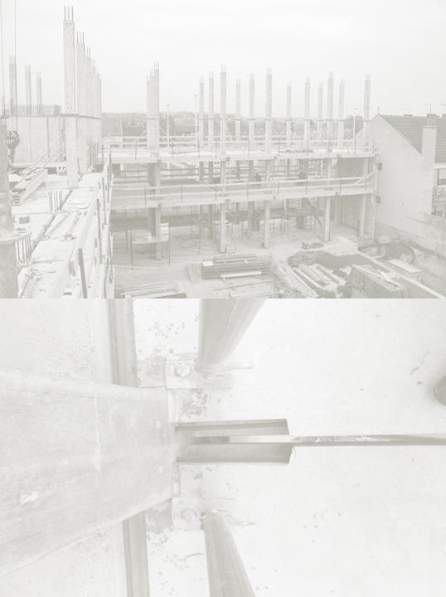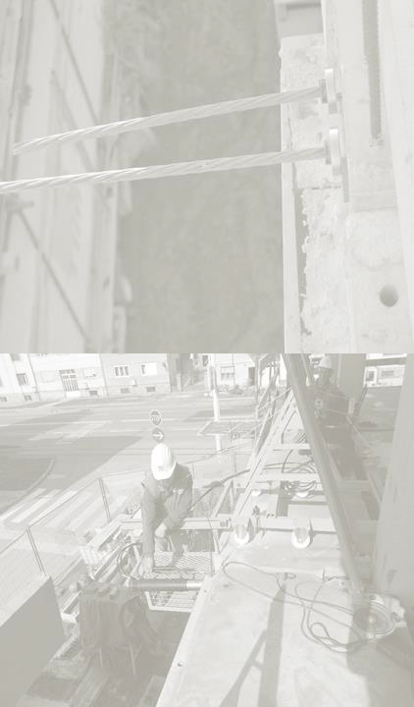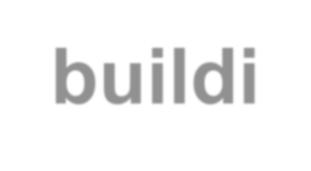Introduction

PTS
building technology
Belgrade, Serbia 2021

PTS Building Technology is an advanced system for industrialized building. It is based on prefabricated reinforced concrete elements of the skeleton structure, joined on-site using post-tensioning tendons.

The prefabricated concrete frame consist of columns, beams, floors slabs, shear walls and staircases. It offers a wide variety of different buildings produced out of relatively small number of typical elements, precasted industrially in large series.

An important characteristic of the PTS Building Technology is that it represents an open system, which can accommodate various subsystems, differing in both technology and materials.

Used in numerous large-scale projects in former Yugoslavia and various parts of the World in the second part of the XX century, named as IMS/PTS Building Technology is the last surviving concrete prefabrication system for housing still in use today.

Key improvements

The modernization of the system, carried out through this project, includes numerous significant technical improvements. Key differences from the previously used technology, that are the result of long-term development and application of the IMS/PTS system, include post-tensioning with the use of tendons, innovations of the elements and joints, production in flexible moulds, innovations of assembly equipment, as well as the use of advanced structural analysis software.

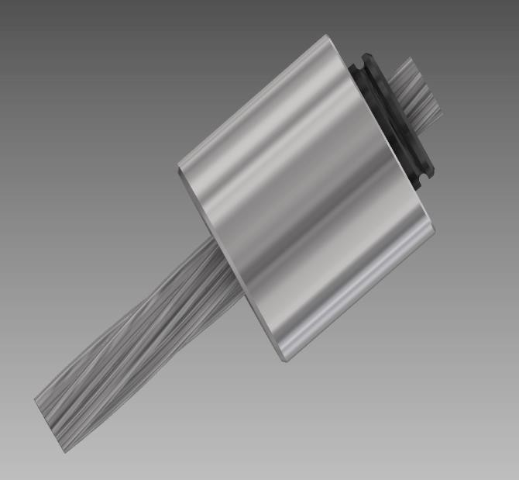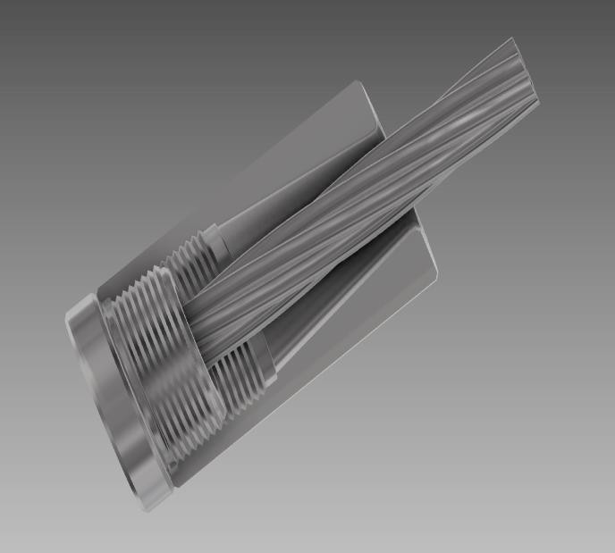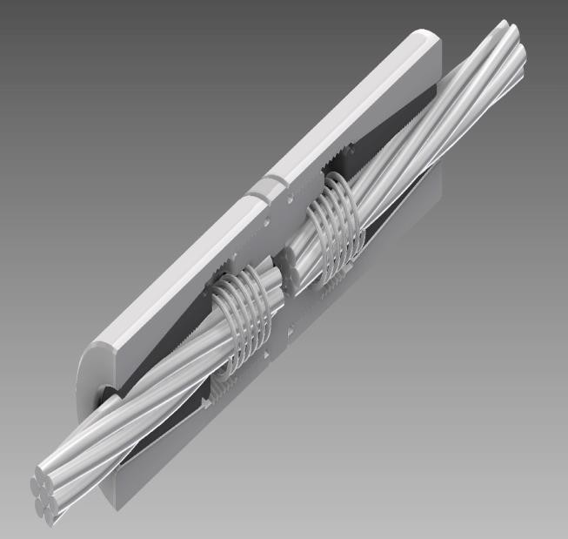Post-tensioning

SPB SUPER pre-stressing/post-tensioning system is implemented, using steel tendons.

Previous solution, used by former Yugoslav’s companies, was based on prestressing of steel wires (IMS/PTS System).

NORMAL FIXED COUPLER

Production of elements

Casting of floor slab elements is done in moulds with interchangeable modular sides.

Some sides are fixed on the side of a steel platform, while others slide over the surface and are fixed in place using special technics.

Simple and quick replacement of sides enables the production of different modules (360 x 360, 360 x
420, 360 x 480, 360 x 540, 420 x 420, 420 x 480 cm)
and even other modules up to 800x800 cm for special
cases.

Simplified elements and assembly

The cross-section of the side of the mould and element is simplified to the maximum extent, in terms of geometry and production and assembly procedures.

The assembly equipment is innovated based on all positive experiences (decreased dimensions, easier operation).

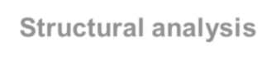Structural analysis

Structural analysis and modeling of the IMS/PTS structure is done using contemporary software and according to European Norms, ACI 318 and NSCP 2015 norms.

It confirmed the experimental results, as well as experiences of several decades of application of the IMS/PTS Building Technology in numerous countries.

The underground structure is realized as cast-in- situ reinforced concrete skeleton, with RC shear walls. On upper levels, the structure is of post- tensioned prefabricated IMS/PTS elements, with only seismic shear walls cast in-situ. The walls can be pre-cast as well.

The staircase was also realized of prefabricated elements – flights and decks, enabling instant vertical communication during works.

Locally, the system was used on the three 22- storey PALM TOWERS in 1997 in San Antonio Village, Makati City, with a total built area of 56,000 square meters.

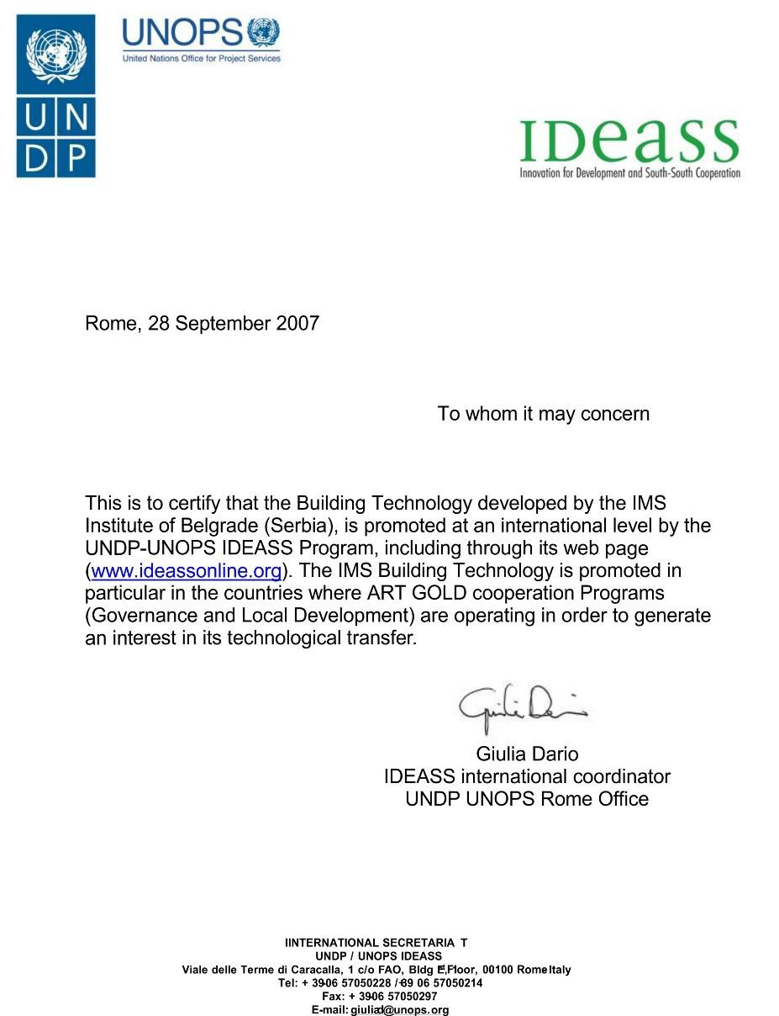Recognition at the Highest Level

Innovation for Development and South-South Cooperation

Among many recognitions, acknowledgements and recommendations all over the world, the PTS-IMS Building Technology takes pride to be admitted and promoted as an advanced building construction technology by the International Cooperation Progamme IDEASS, (UNDP-UNOPS-ILO
sponsored), on 28 of September 2007, in Rome, Italy.

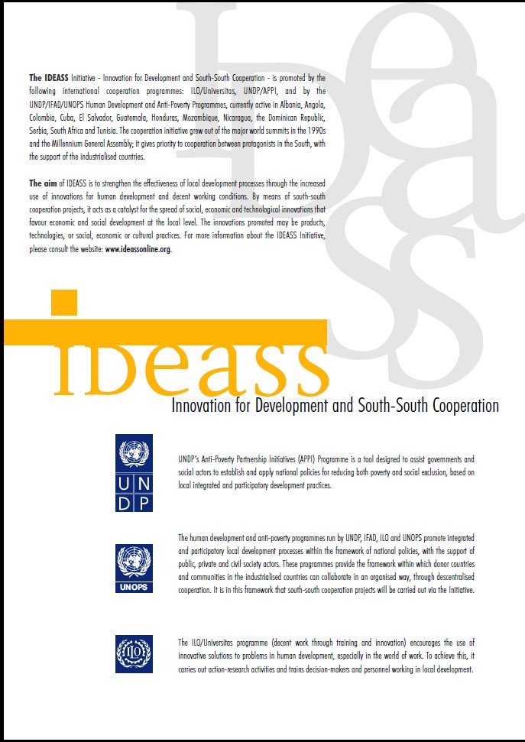Recognition at the Highest Level
Innovation for Development and South-South Cooperation

The PTS-IMS Building Technology was being recommended and promoted at an international level for execution of construction projects financed by both governments and private sectors worldwide.

This prestigious recognition of the PTS-IMS Building Technology came about as a result of its extensive worldwide experience the past so many decades with its environmentally friendly approach and the use of innovative solutions to address concerns on human development , especially in the field of labor.

Prefabricated façade panels

An important innovation that Client wanted to implement at the same time is the use of thermally insulated prefabricated reinforced concrete façade panels. These three-layer panels were featured in both first and second project and designed to meet the strict new energy efficiency regulations (e.g. absolutely no thermal bridges).

The design of prefabricated façade panels was also done by the IMS Institute.

Panels consist of a load-bearing RC layer of 9 cm, an insulating layer of extruded polistyrene (XPS) of 10 cm and the façade layer of 6 cm.

The visible façade layer is designed as béton-brût, with smooth or moulded surfaces.

Moulding of surfaces was done using rubber
formliners inserted in production moulds.

The connection of layers is acheived using HALFEN anchoring products – stainless steel cylinders and pins.

The inner and outer concrete layers do not meet at
any point.

Façade panels design also ensures that the whole structure is covered with a continuous thermal insulating layer.

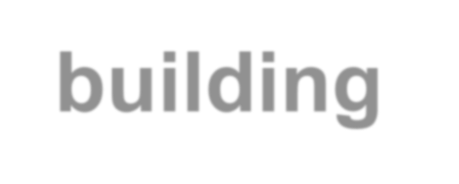Short overview of
precast elements

PTS
building technology
Belgrade, Serbia 2021

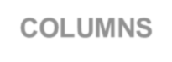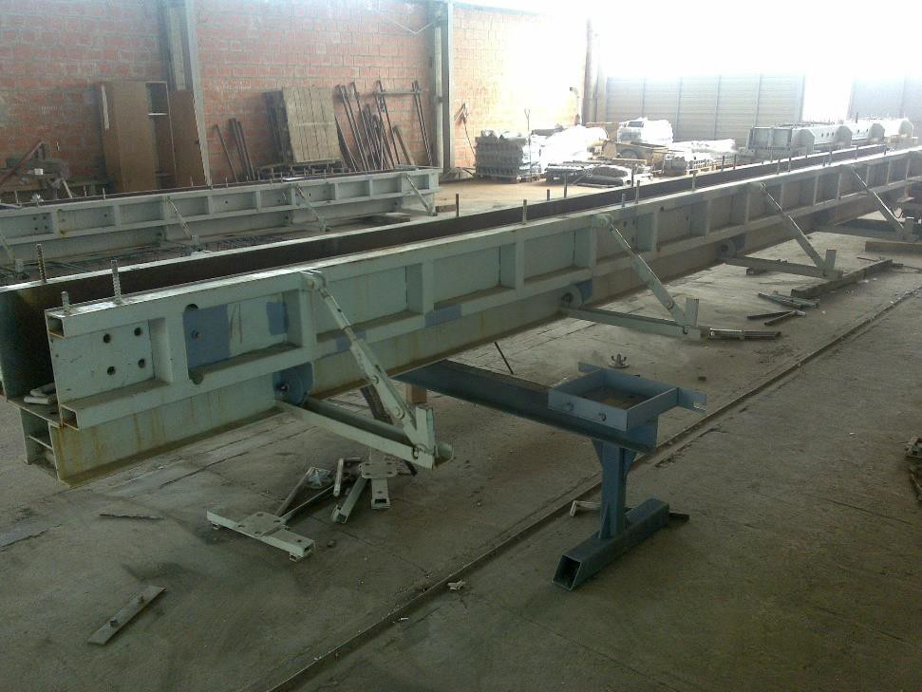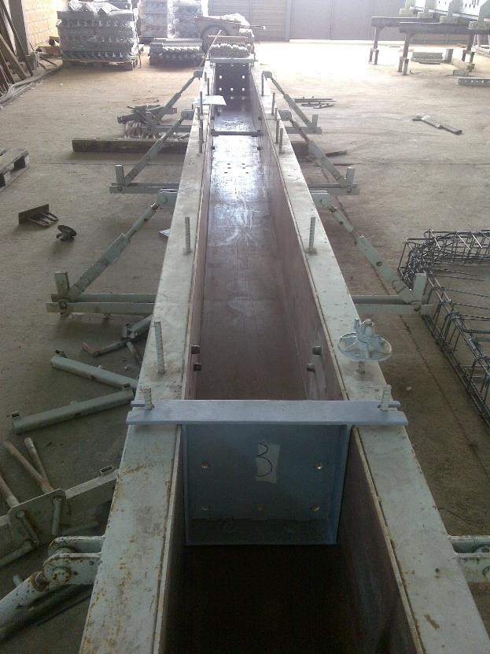COLUMNS-CS

Column steel moulds,
- Production,
- Storing,
- Assembling.
- Waiting for other elements

Column steel moulds in Production Facilities

Generally, three kind of columns are available :
  - One storey column,
  - Two storey column,
  - Three storey column.

COLUMNS-CS
- Column steel moulds,
- Production,

Storing,
- Assembling.
- Waiting for other elements

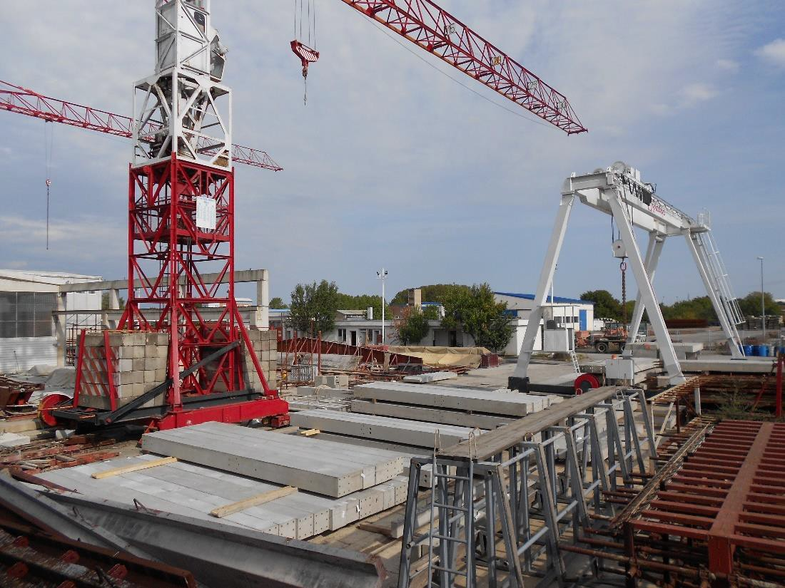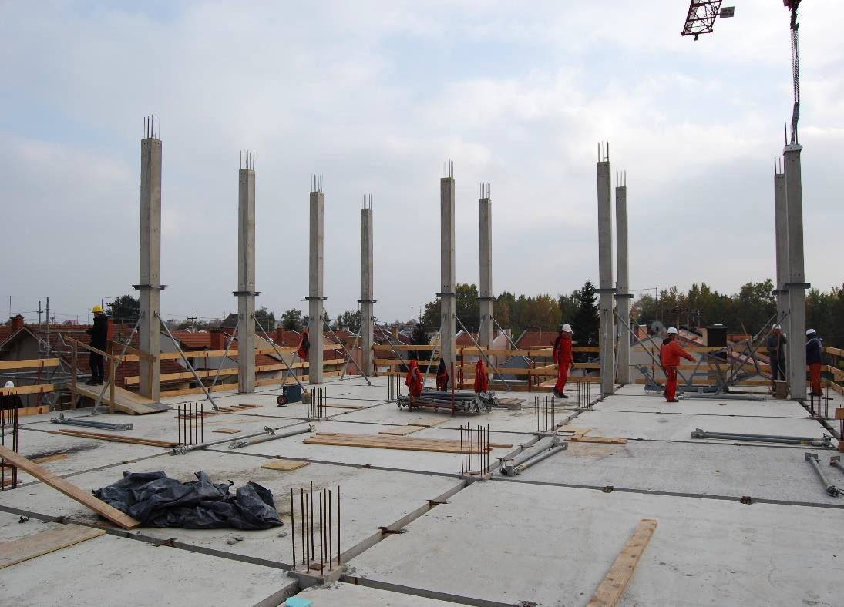Column assembling on site

Column storing at stock area

Generally, three kind of columns are available :
- One storey column,
- Two storey column,
- Three storey column.

FLOOR SLABS-FS

FS steel moulds,
  - Production,
  - Storing,
  - Assembling.
  - Special activities

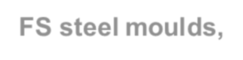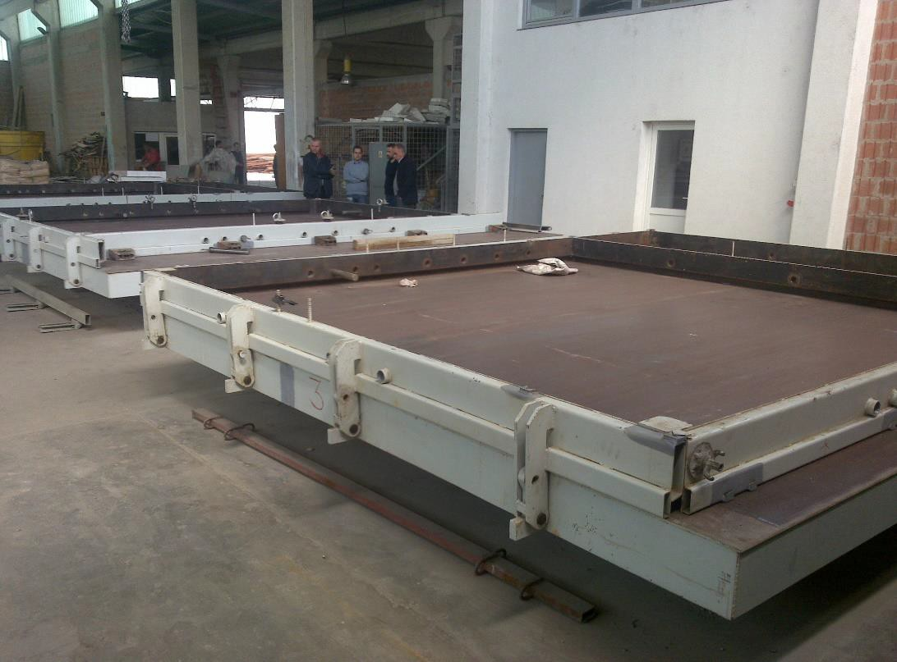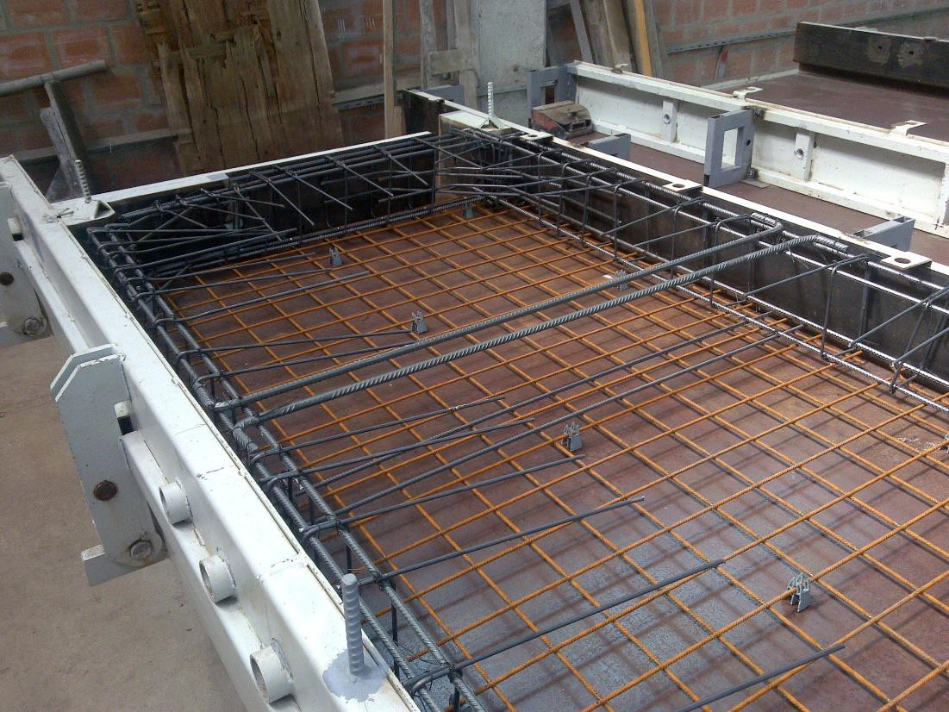FS reinforcement in Production Facilities

FS steel moulds in Production Facilities

Generally, various kind of floor slabs as a solution are possible :
- One FS with dimensions up to 6x4 m,
- Two FS slabs integrated as one 2x2.5x8 m,
- Three FS slabs integrated as one 3x2.5x8 m

Note: The transportation limit width is 2.5 m, there are also possibility to have bigger up to
3m.

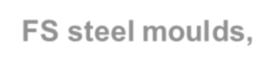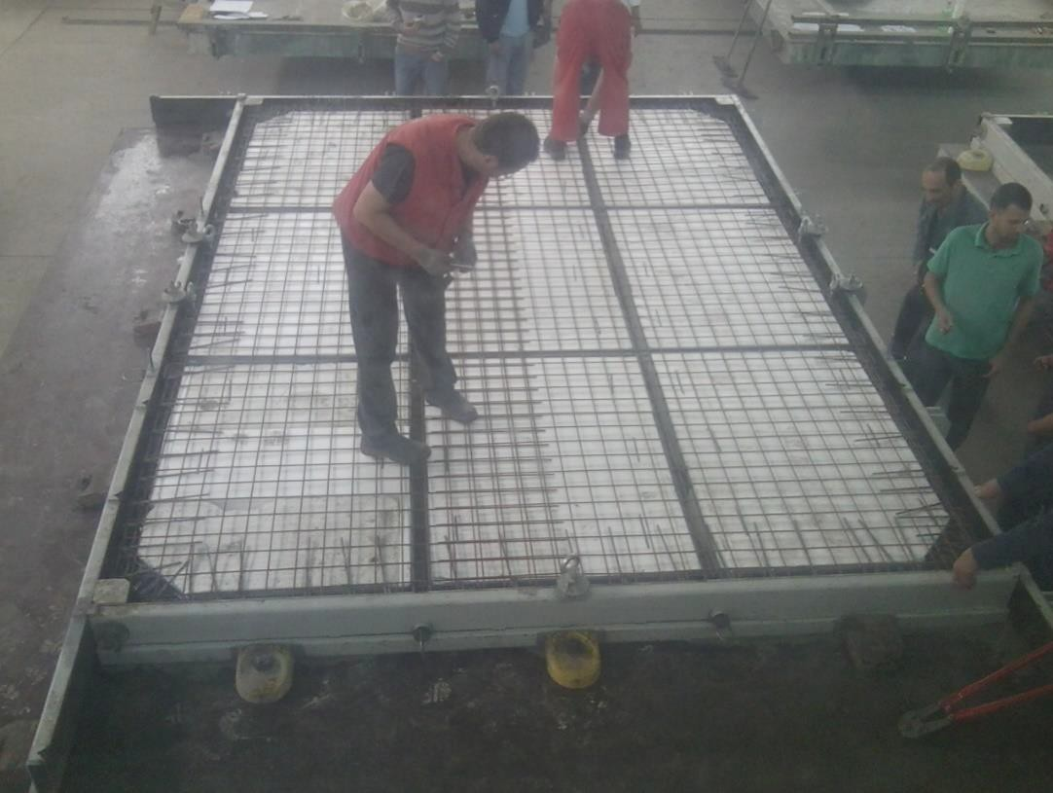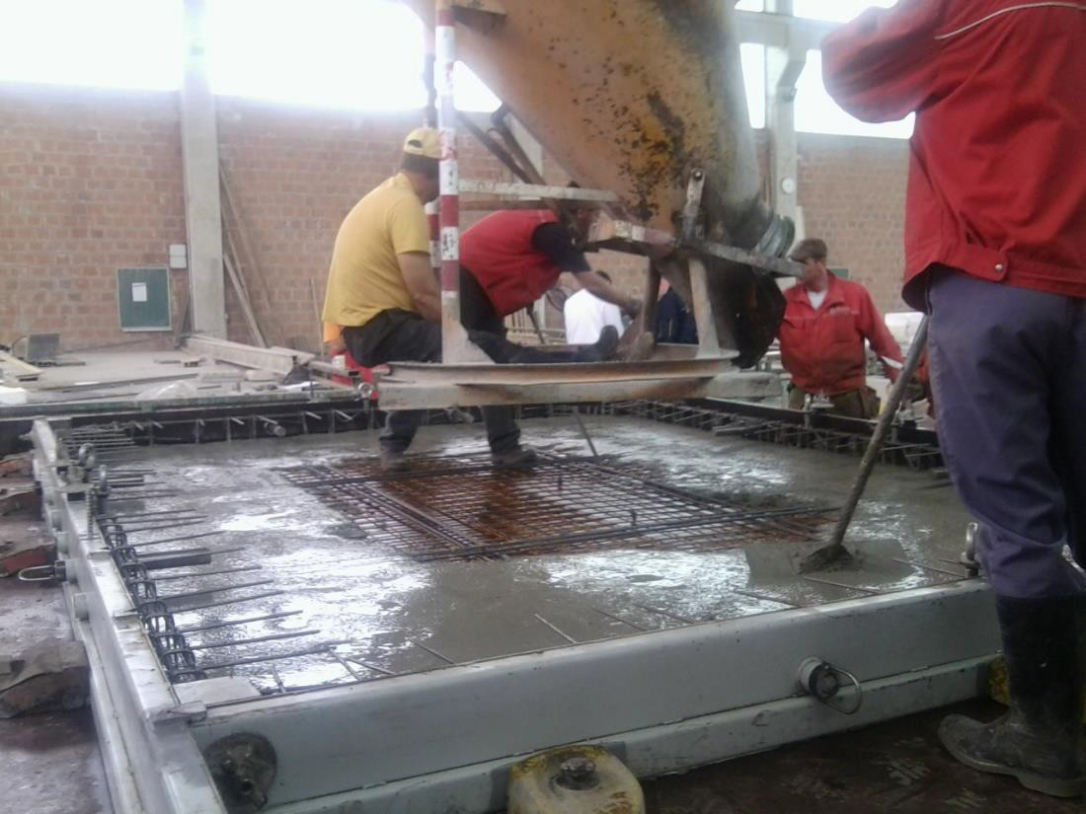FLOOR SLABS-FS

FS steel moulds,
  - Production,
  - Storing,
  - Assembling.
  - Special activities

FS concreting phase

FS pre-concreting phase –EPS insulation

Generally, various kind of floor slabs as a solution are possible :
- One FS with dimensions up to 6x4 m,
- Two FS slabs integrated as one 2x2.5x8 m,
- Three FS slabs integrated as one 3x2.5x8 m

Note: The transportation limit width is 2.5 m, there are also possibility to have bigger up to
3m.

FLOOR SLABS-FS
  - FS steel moulds,
  - Production,

Storing,
  - Assembling.
  - Special activities

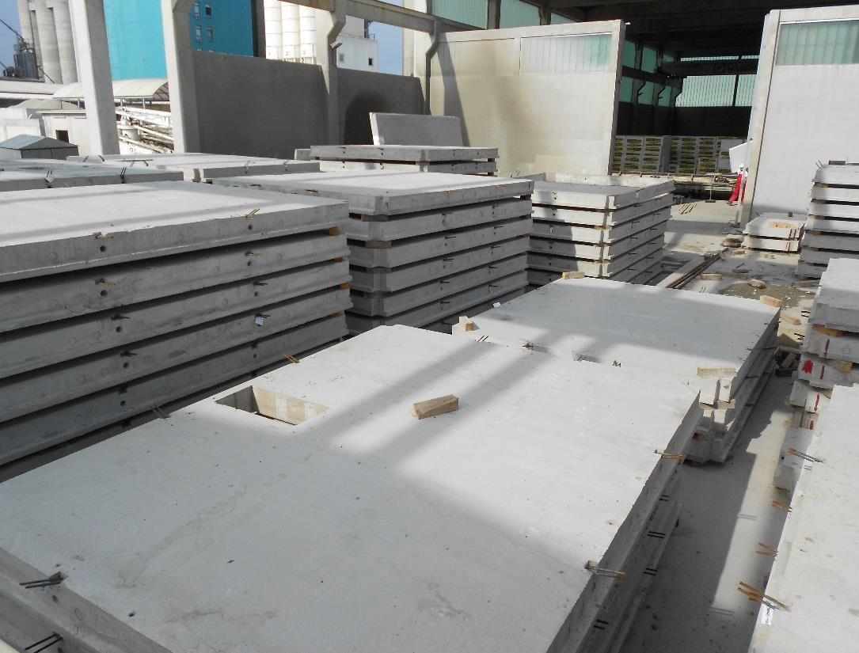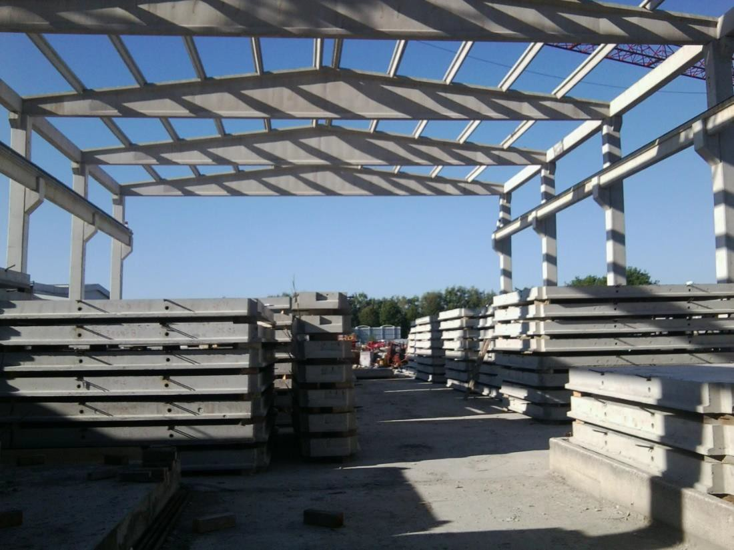FS elements storing at stock area

FS elements storing at stock area
Generally, various kind of floor slabs as a solution are possible :
- One FS with dimensions up to 6x4 m,
- Two FS slabs integrated as one 2x2.5x8 m,
- Three FS slabs integrated as one 3x2.5x8 m

Note: The transportation limit width is 2.5 m, there are also possibility to have bigger up to 3m.

FLOOR SLABS-FS
  - FS steel moulds,
  - Production,
  - Storing,

Transporting/Assembling,
  - Special activities

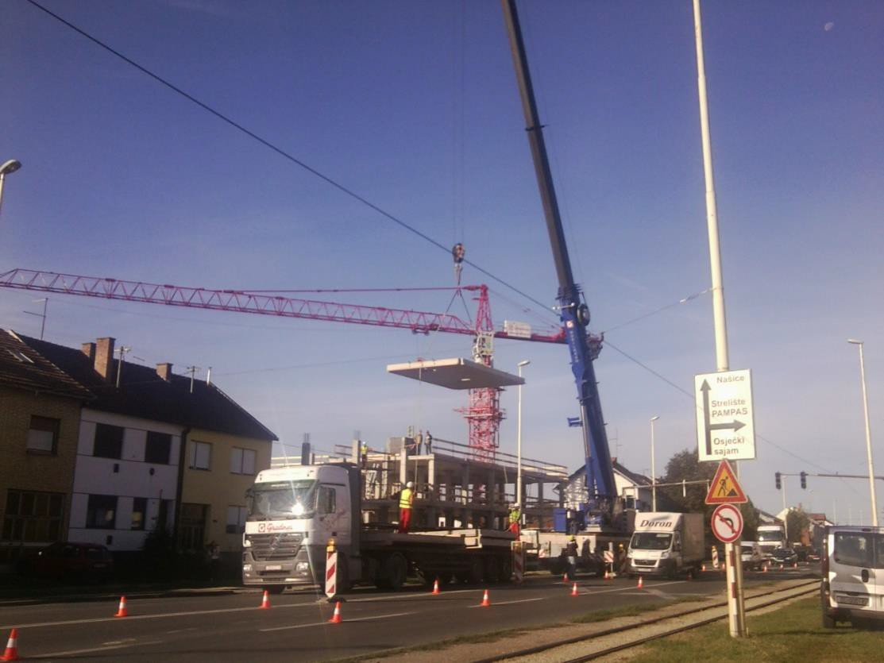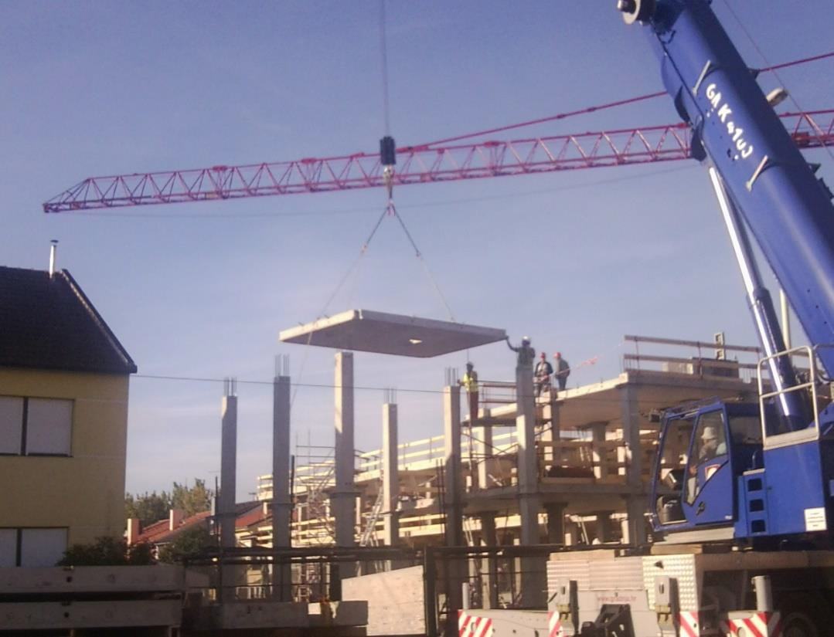FS elements during assembling

FS elements transporting
Generally, various kind of floor slabs as a solution are possible :
- One FS with dimensions up to 6x4 m,
- Two FS slabs integrated as one 2x2.5x8 m,
- Three FS slabs integrated as one 3x2.5x8 m

Note: The transportation limit width is 2.5 m, there are also possibility to have bigger up to 3m.

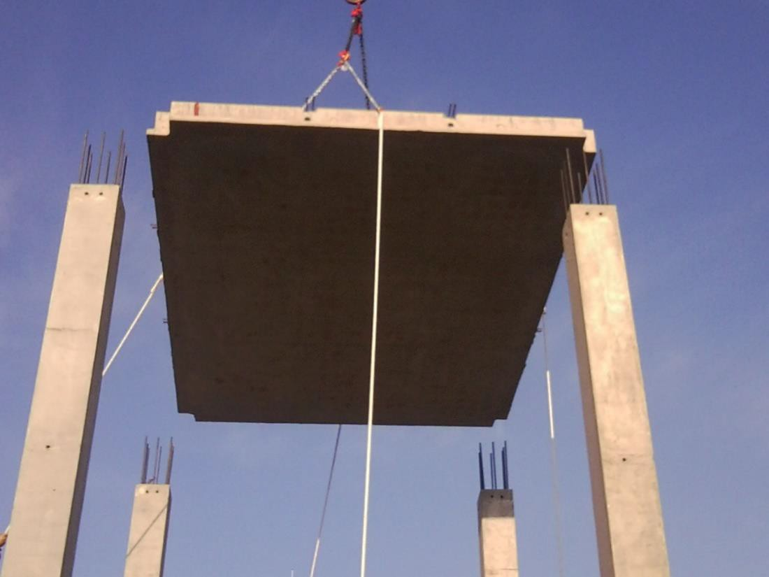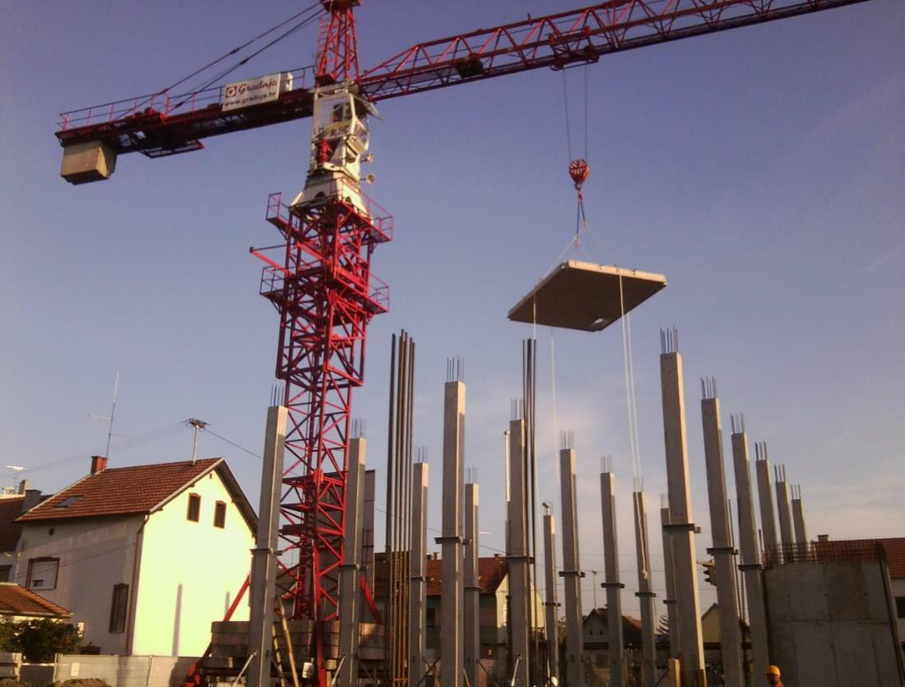FLOOR SLABS-FS
  - FS steel moulds,
  - Production,
  - Storing,

Transporting/Assembling,
  - Special activities

FS elements during assembling

FS elements transporting
Generally, various kind of floor slabs as a solution are possible :
- One FS with dimensions up to 6x4 m,
- Two FS slabs integrated as one 2x2.5x8 m,
- Three FS slabs integrated as one 3x2.5x8 m

Note: The transportation limit width is 2.5 m, there are also possibility to have bigger up to 3m.

FLOOR SLABS-FS
  - FS steel moulds,
  - Production,
  - Storing,

Transporting/Assembling,
  - Special activities

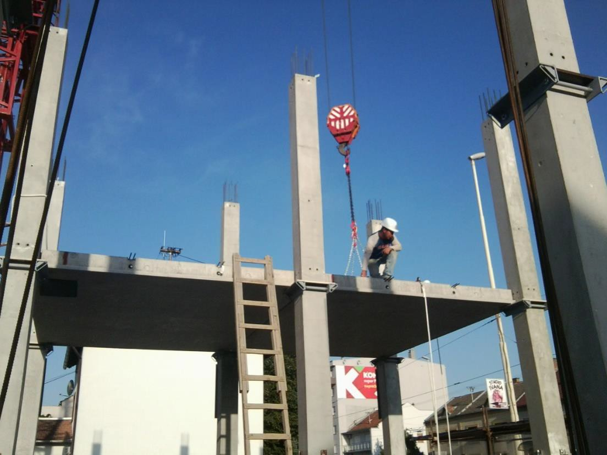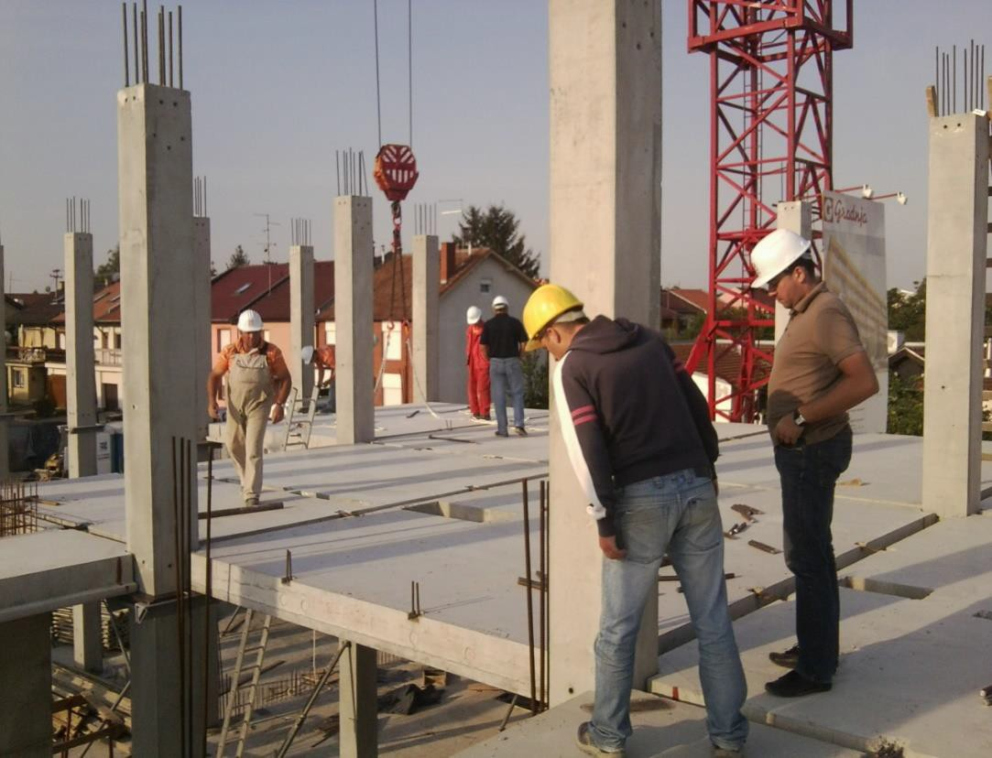FS elements during assembling

FS elements transporting
Generally, various kind of floor slabs as a solution are possible :
- One FS with dimensions up to 6x4 m,
- Two FS slabs integrated as one 2x2.5x8 m,
- Three FS slabs integrated as one 3x2.5x8 m

Note: The transportation limit width is 2.5 m, there are also possibility to have bigger up to 3m.

FLOOR SLABS-FS
  - FS steel moulds,
  - Production,
  - Storing,

Transporting/Assembling,
  - Special activities

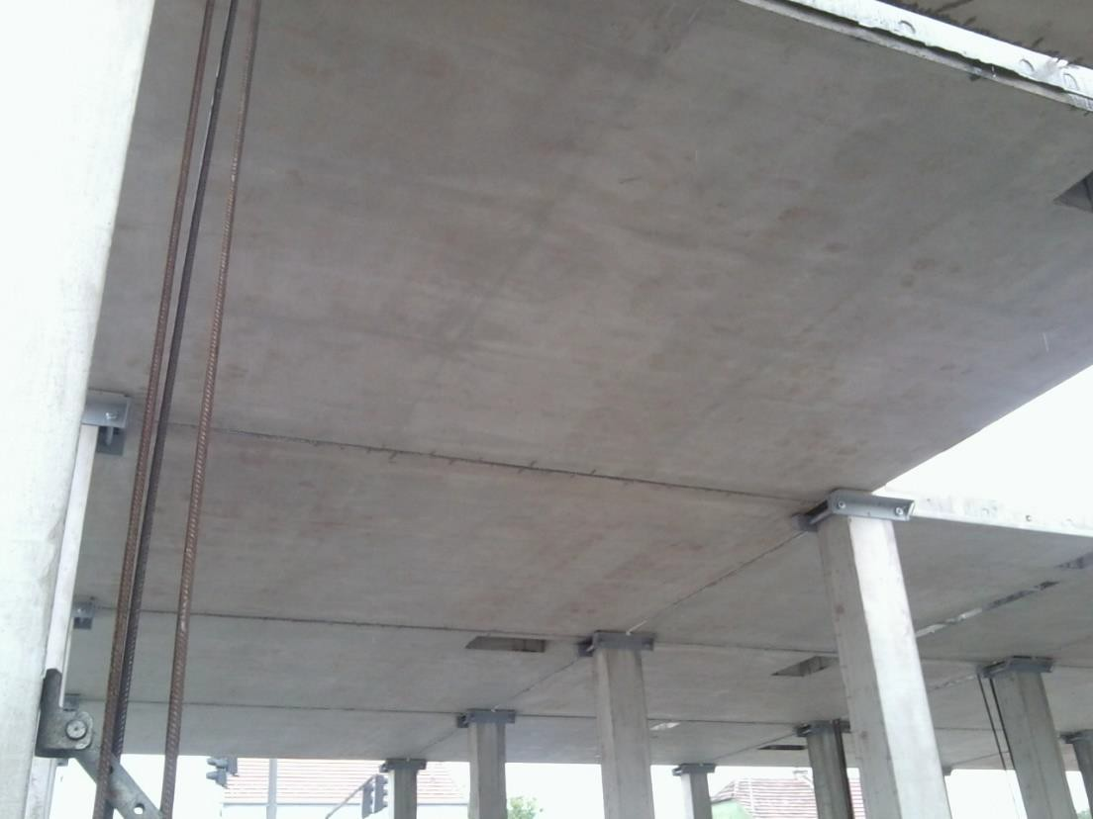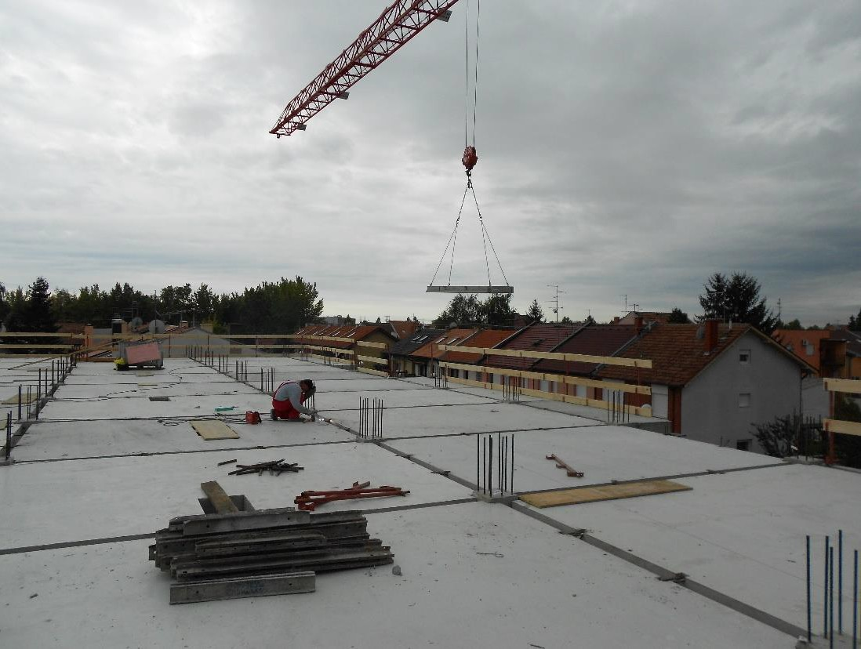FS elements and CS elements due assembling

FS elements on temporary supports
Generally, various kind of floor slabs as a solution are possible :
- One FS with dimensions up to 6x4 m,
- Two FS slabs integrated as one 2x2.5x8 m,
- Three FS slabs integrated as one 3x2.5x8 m
- Cantilever slabs CS up to 2.5m span

Note: The transportation limit width is 2.5 m, there are also possibility to have bigger up to 3m.

FLOOR SLABS-FS
  - FS steel moulds,
  - Production,
  - Storing,

Transporting/Assembling,
  - Special activities

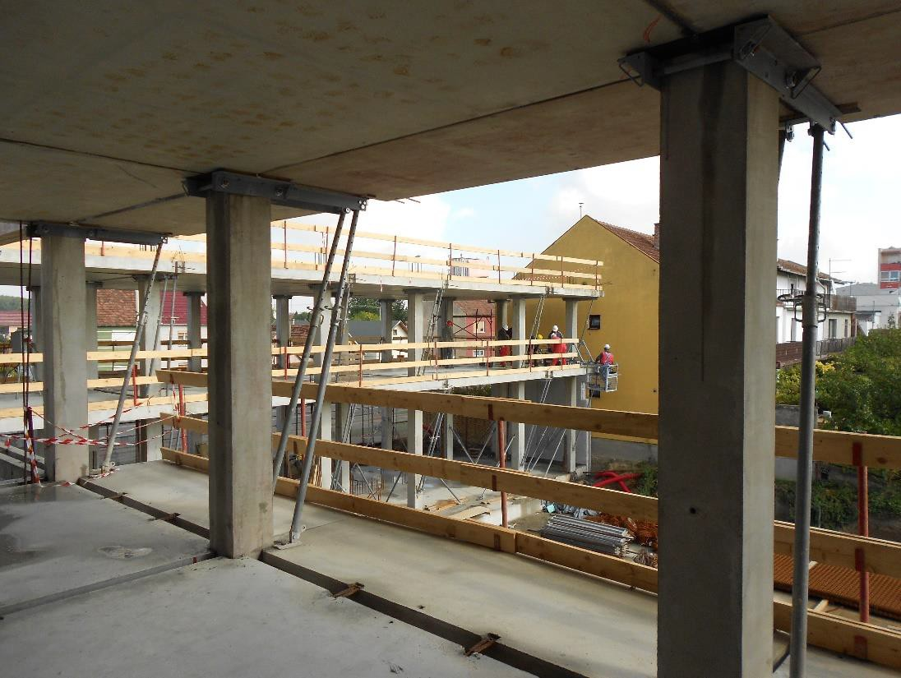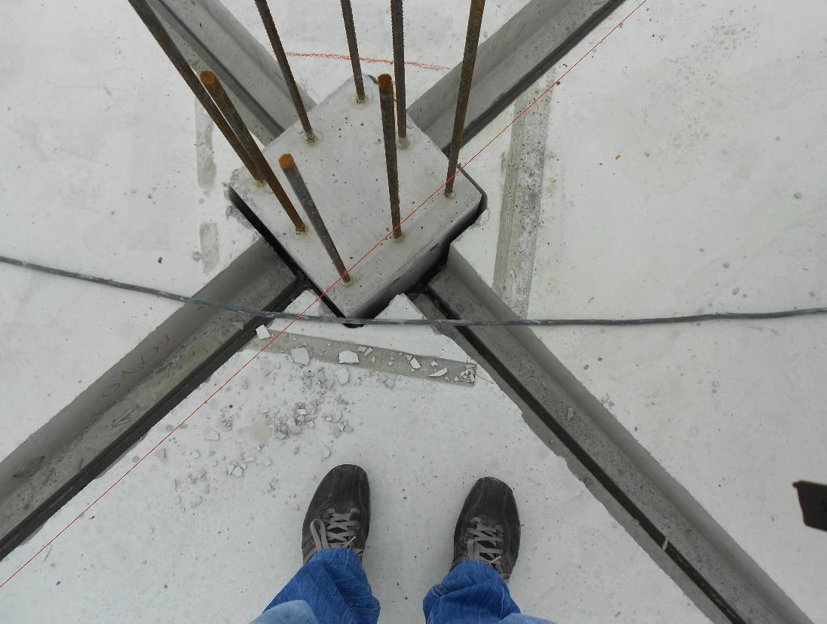FS elements and CS elements due assembling

FS elements on temporary supports
Generally, various kind of floor slabs as a solution are possible :
- One FS with dimensions up to 6x4 m,
- Two FS slabs integrated as one 2x2.5x8 m,
- Three FS slabs integrated as one 3x2.5x8 m
- Cantilever slabs CS up to 2.5m span

Note: The transportation limit width is 2.5 m, there are also possibility to have bigger up to 3m.

FLOOR SLABS-FS
  - FS steel moulds,
  - Production,
  - Storing,
  - Transporting/Assembling,

Special activities

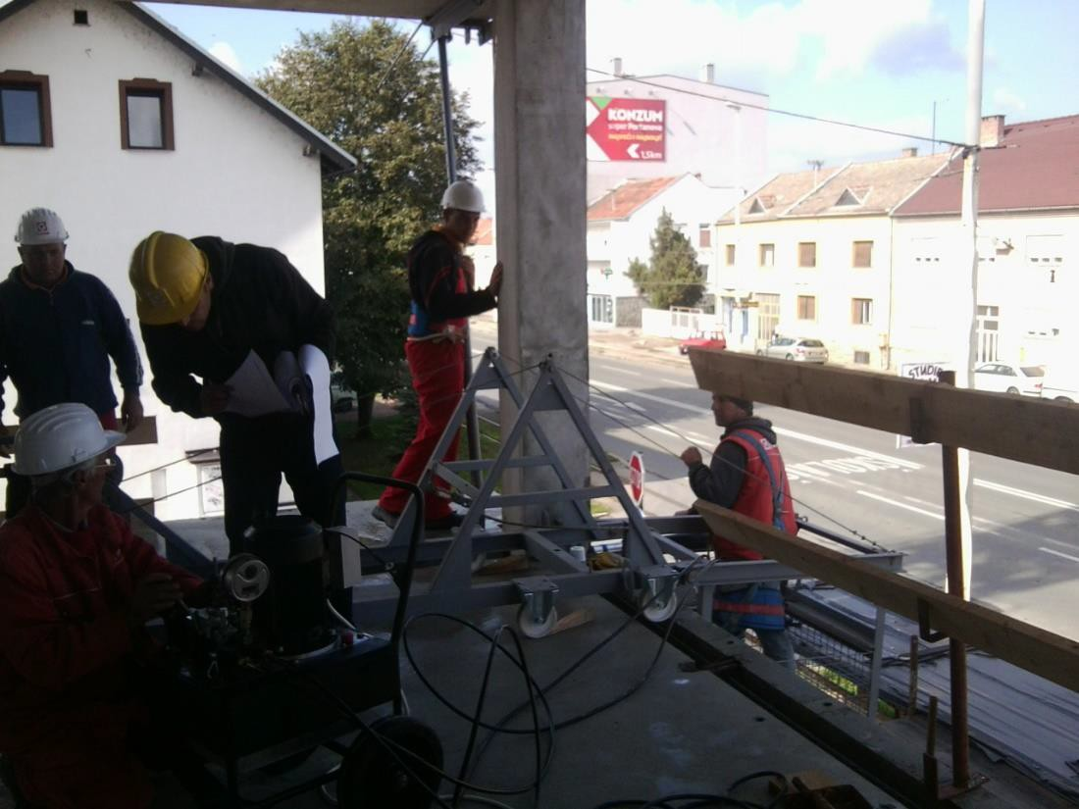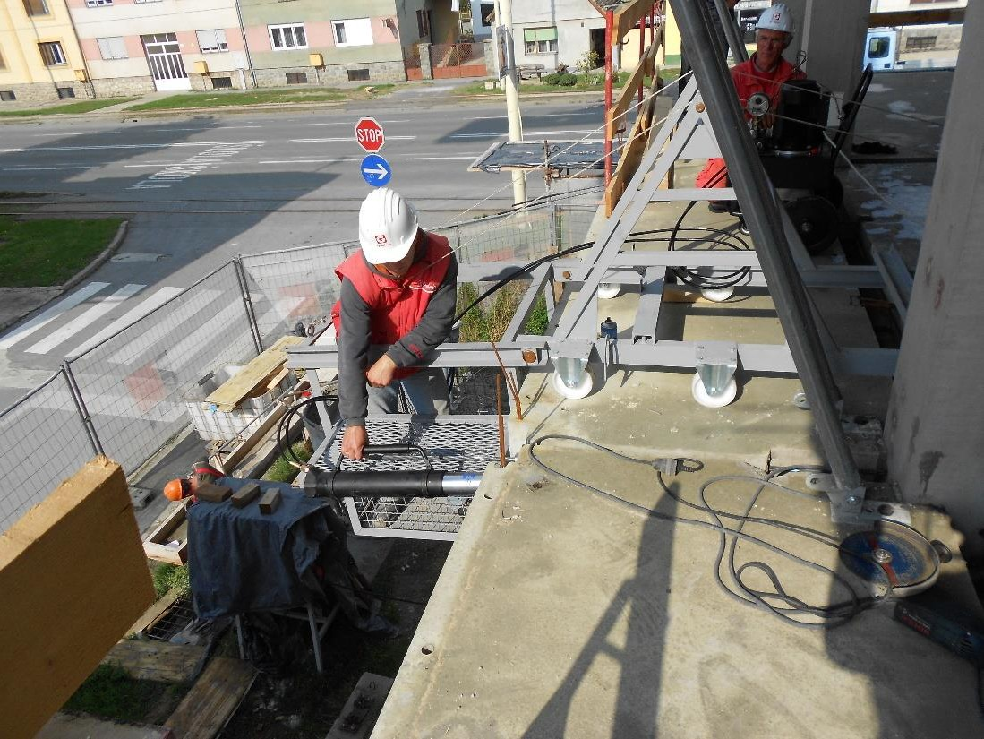Post-tensioning

Post-tensioning
Special activities consist a few steps:
- The tendons positioning,
- Joint connection activities,
- post-tension action,
- System line grouting actions.

Note: The tendons are going through predefined holes with design eccentricity and with special equipment for push-down actions.

FLOOR SLABS-FS
  - FS steel moulds,
  - Production,
  - Storing,
  - Transporting/Assembling,

Special activities

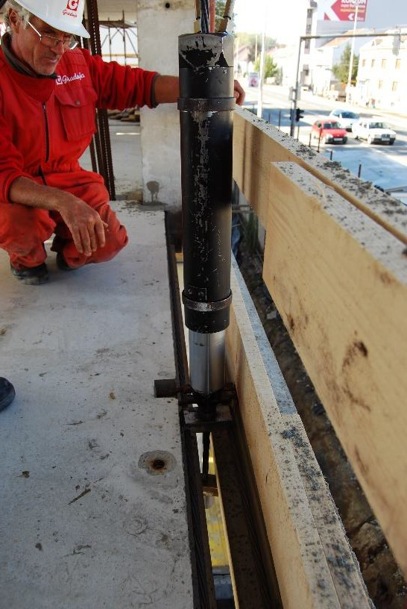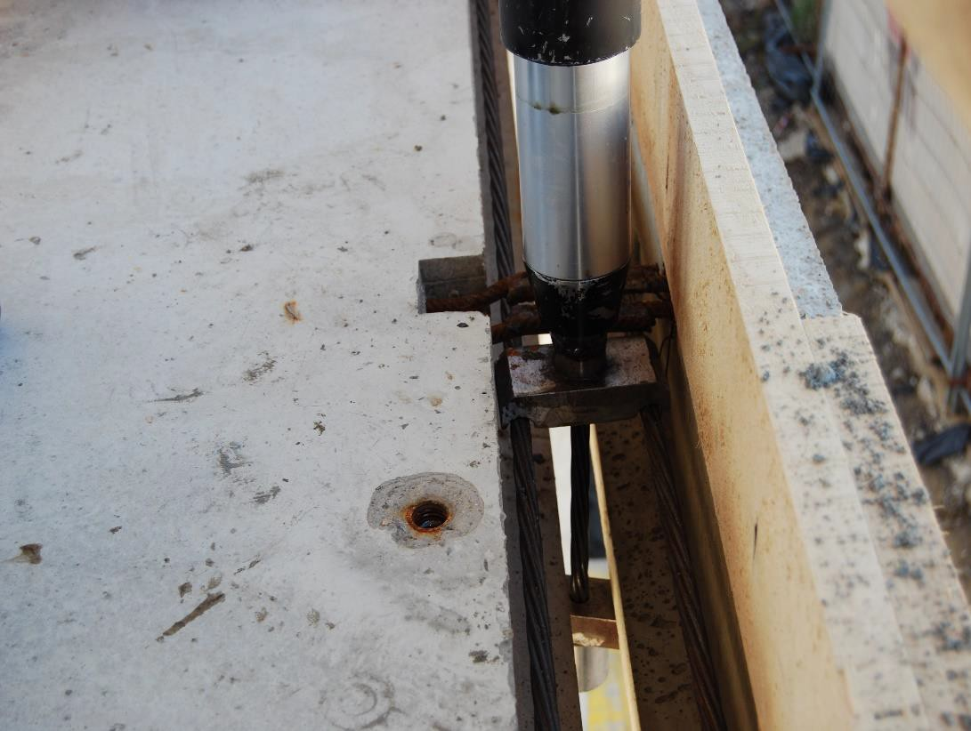Post-tensioning

Post-tensioning
Special activities consist a few steps:
- The tendons positioning,
- Joint connection activities,
- post-tension action,
- System line grouting actions.

Note: The tendons are going through predefined holes with design eccentricity and with special equipment for push-down actions.

FLOOR SLABS-FS
  - FS steel moulds,
  - Production,
  - Storing,
  - Transporting/Assembling,

Special activities

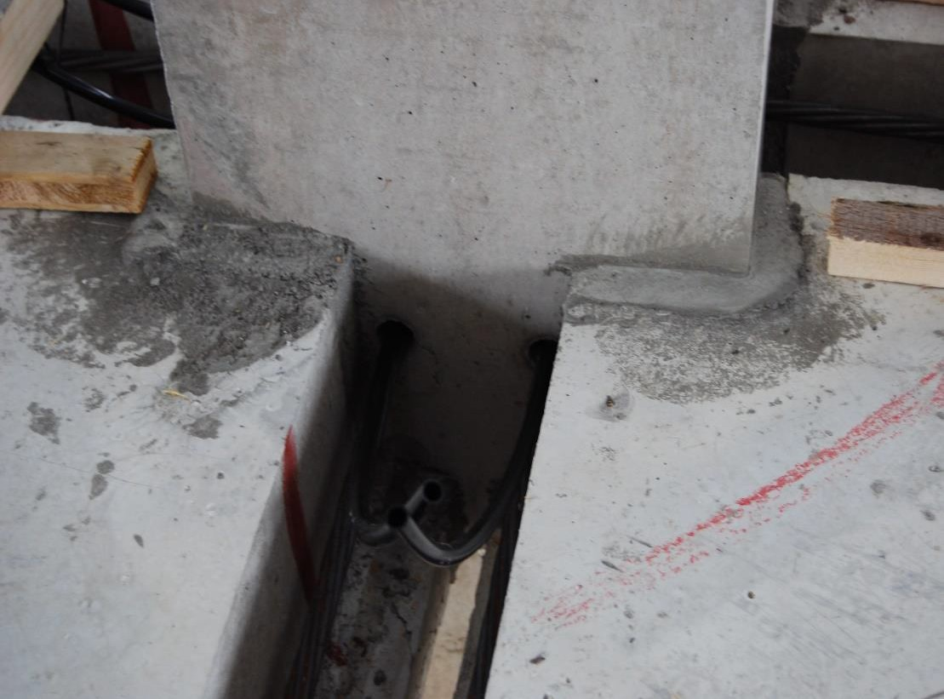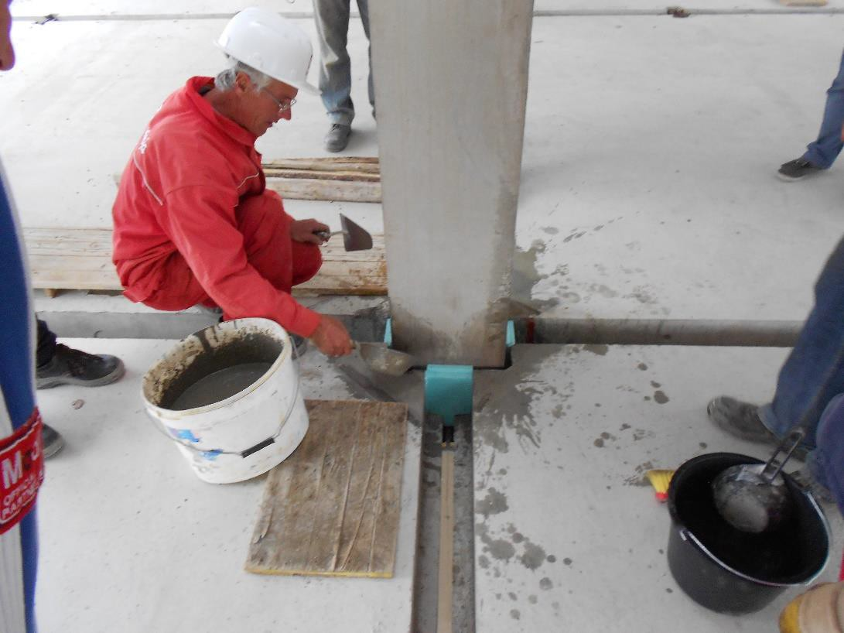Joint connection activities

Joint connection activities
Special activities consist a few steps:
- The tendons positioning,
- Joint connection activities,
- post-tension action,
- System line grouting actions.

Note: The tendons are going through predefined holes with design eccentricity and with special equipment for push-down actions.

FLOOR SLABS-FS
  - FS steel moulds,
  - Production,
  - Storing,
  - Transporting/Assembling,

Special activities

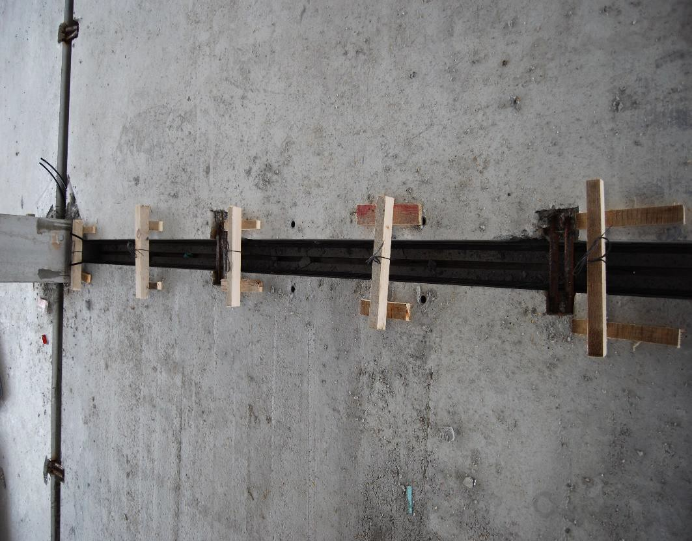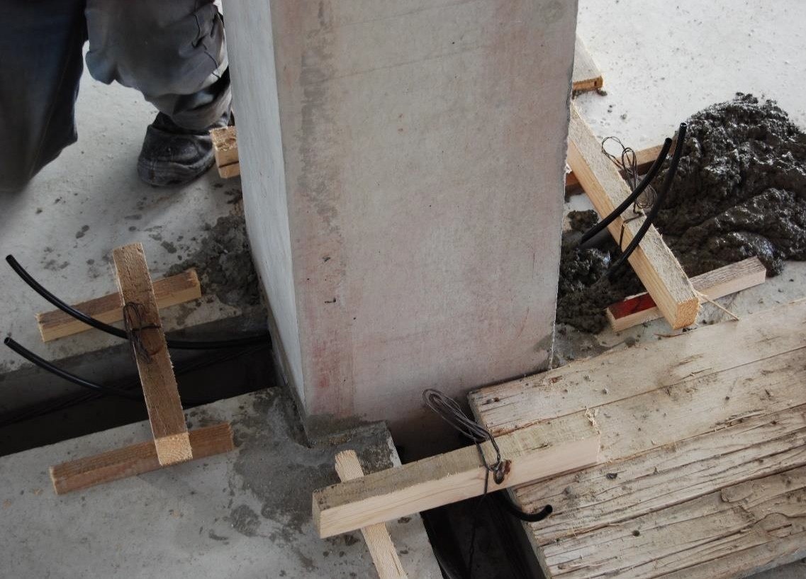System line grouting actions

System line grouting actions
Special activities consist a few steps:
- The tendons positioning,
- Joint connection activities,
- post-tension action,
- System line grouting actions.

Note: The tendons are going through predefined holes with design eccentricity and with special equipment for push-down actions.

OTHER ELEMENTS-EG,ST

Edge girders,
- Stairs,
- Façade walls,

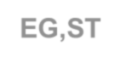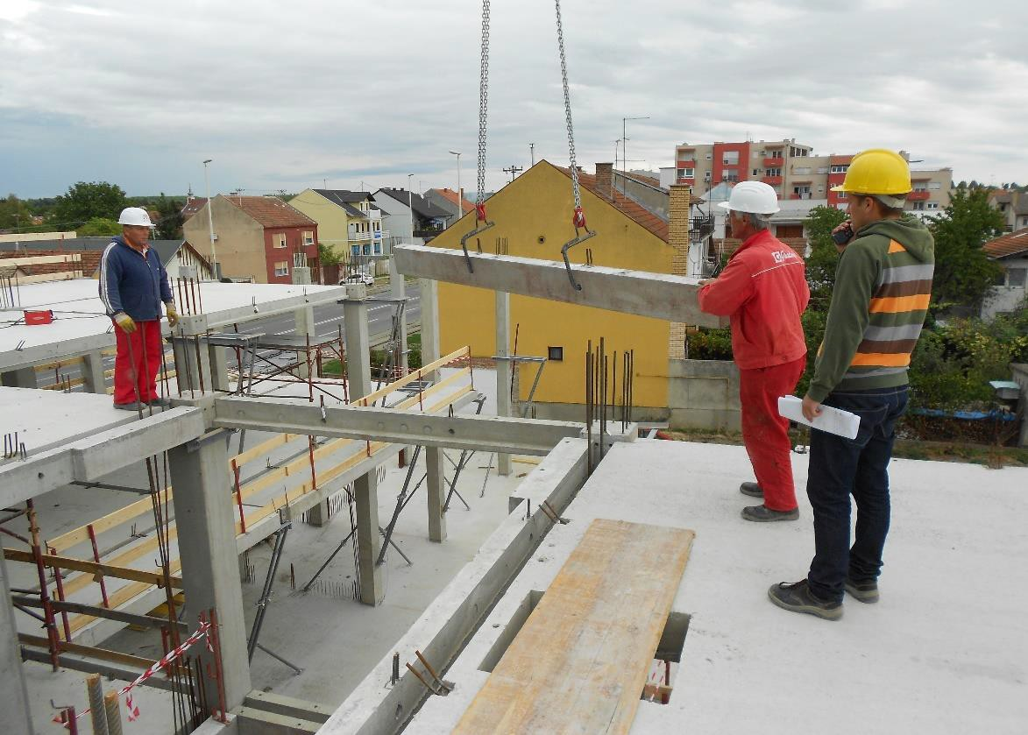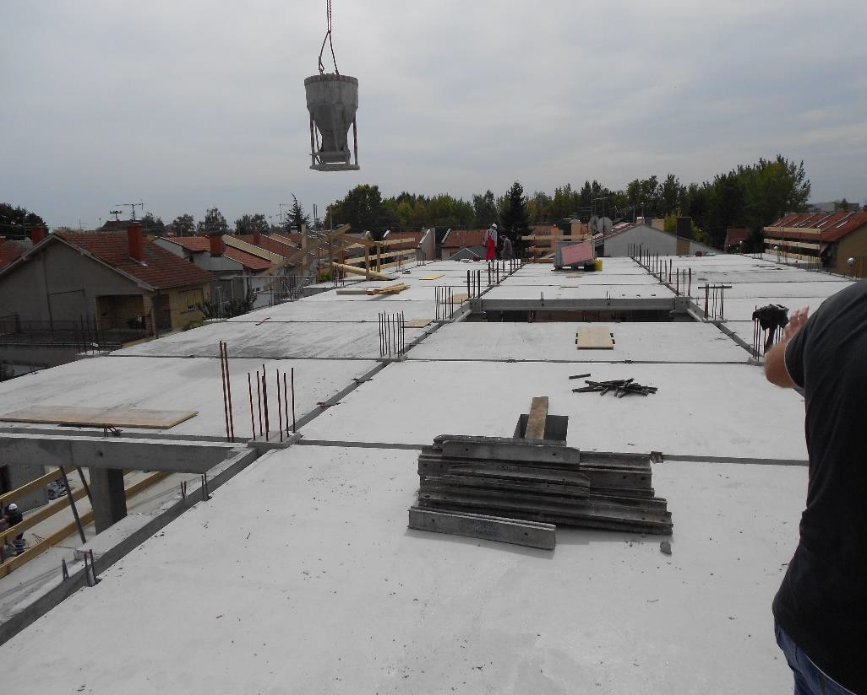System line grouting actions

System line grouting actions
Edge girders are defining the edge of structure
- They can have various shape,
- They have one side identical to FS,
- They can be also the support for facades,

OTHER ELEMENTS-EG,ST
  - Edge girders,

Stairs,
  - Façade walls,

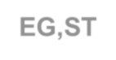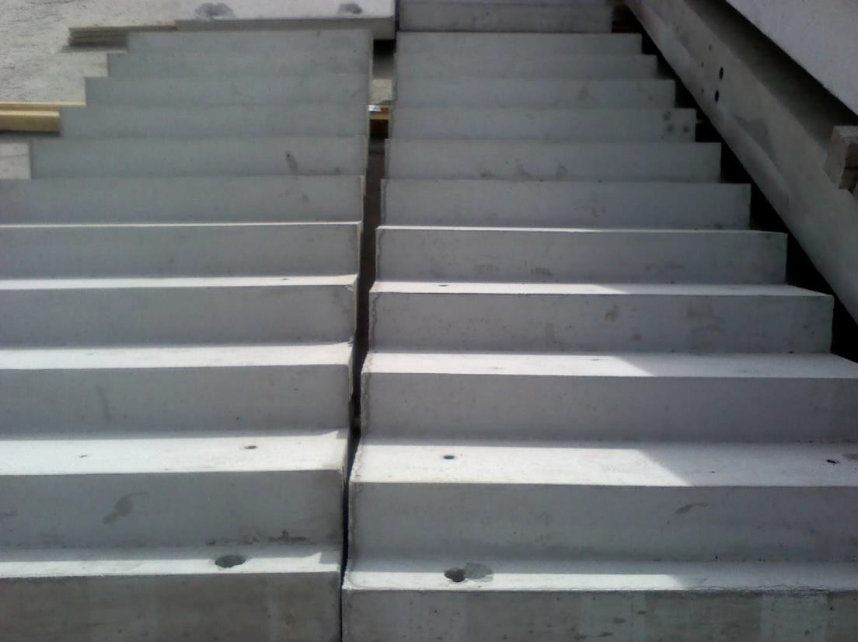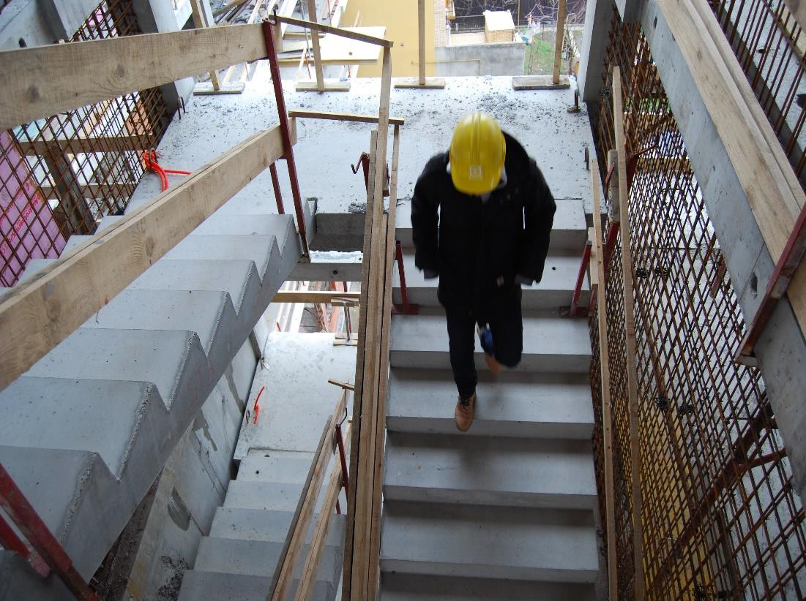Stairs on stock area

Precast stairs
Stairs can have desired shape
- The steps have the same dimensions,
- Very easy installing and supporting

OTHER ELEMENTS-EG,ST
- Edge girders,
- Stairs,

Façade walls,

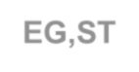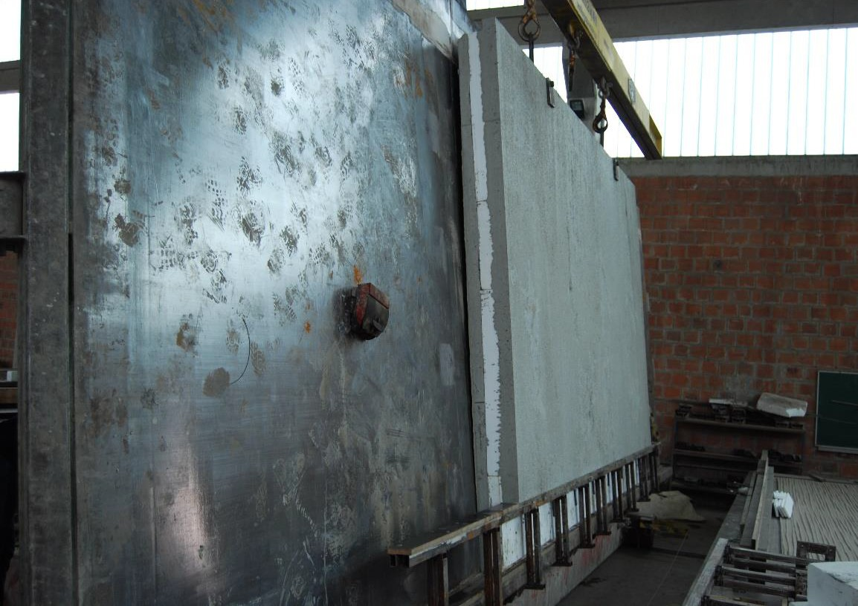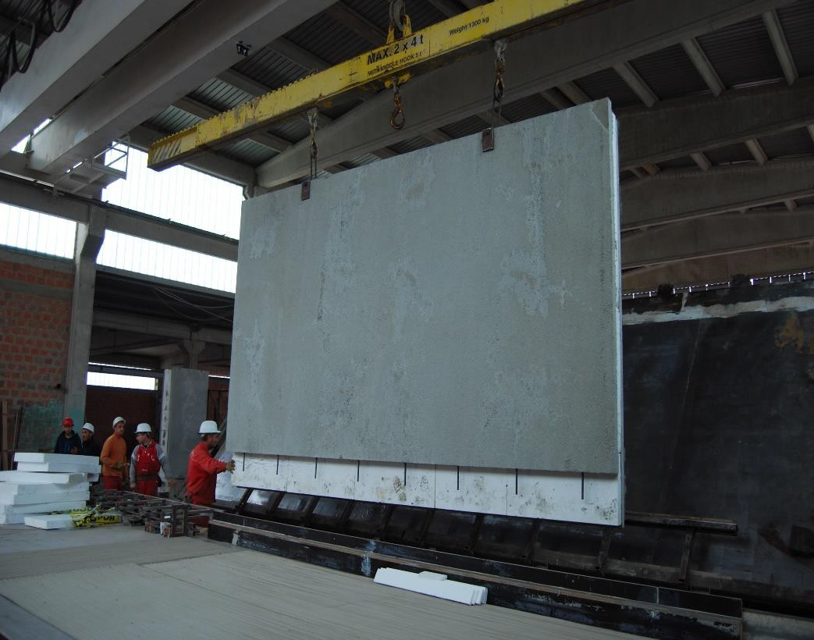Three sandwich façade walls-production

Three sandwich façade walls-production
Façade elements can be with one, two or three layers.
- The exterior part can be with any texture,
- There are possibility to have pre-defined openings for the doors, windows.

OTHER ELEMENTS-EG,ST
  - Edge girders,
  - Stairs,

Façade walls,

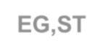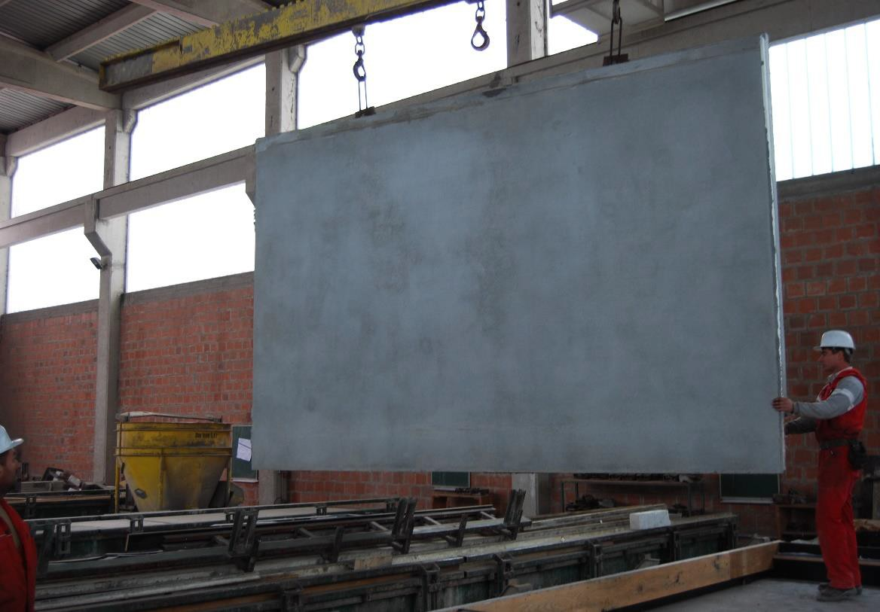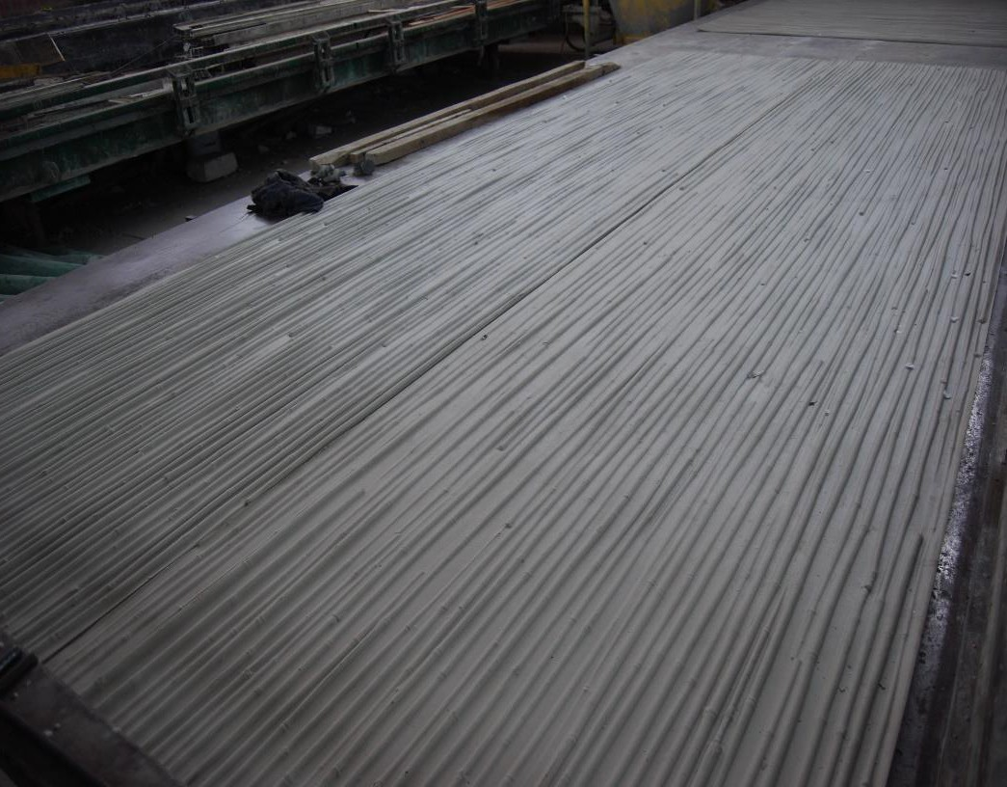The outer façade texture

The plane outer façade surface
Façade elements can be with one, two or three layers.
- The exterior part can be with any texture,
- There are possibility to have pre-defined openings for the doors, windows.

OTHER ELEMENTS-EG,ST
  - Edge girders,
  - Stairs,

Façade walls,

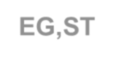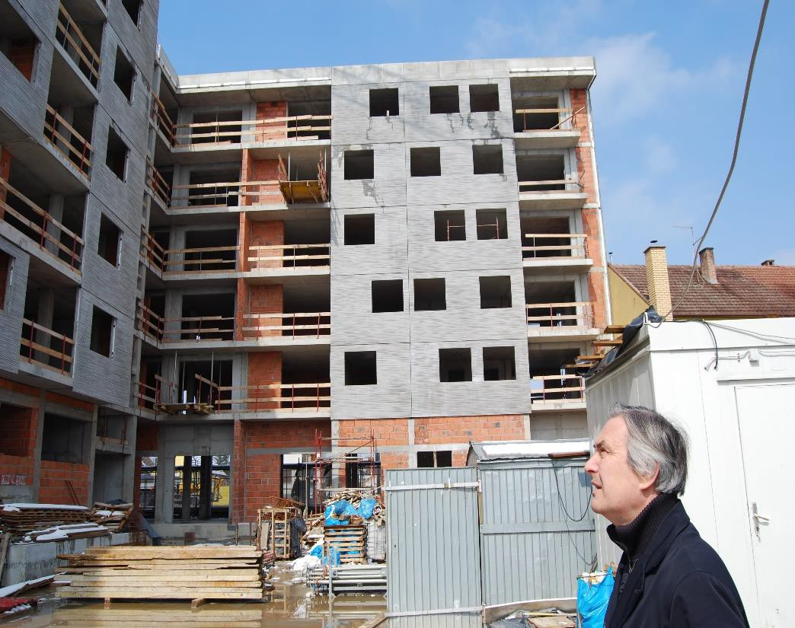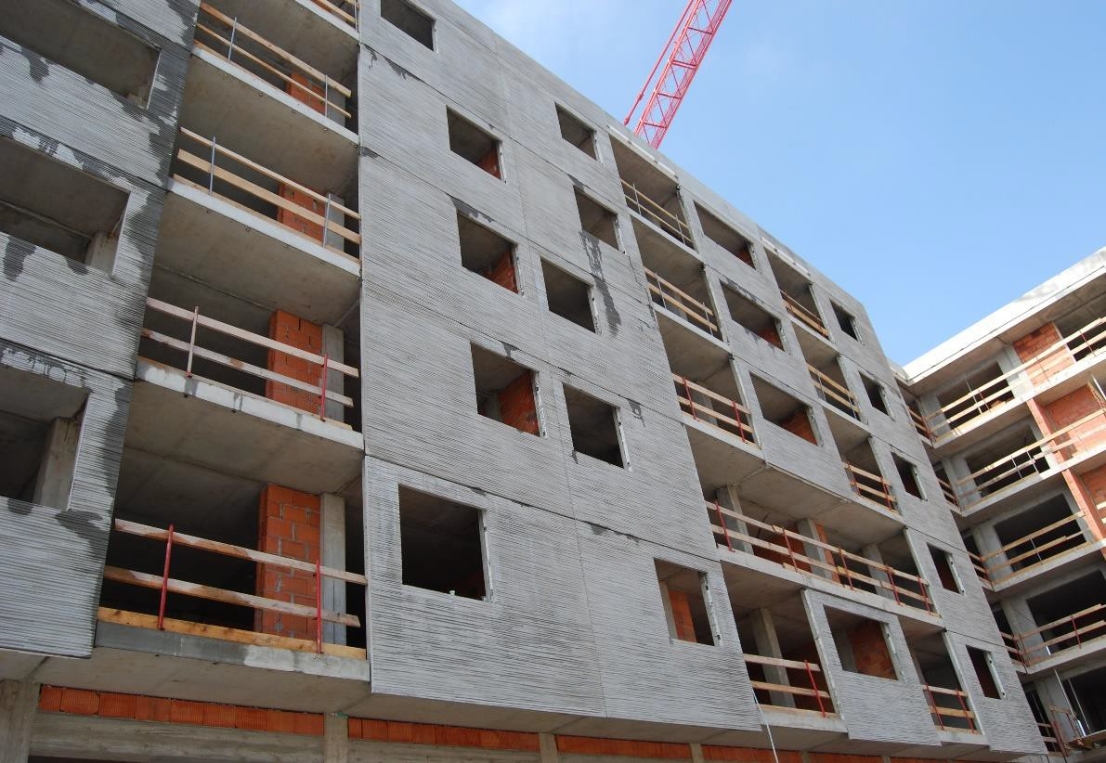The outer façade texture

The outer façade texture with predefined openings
Façade elements can be with one, two or three
layers.
- The exterior part can be with any texture,
- There are possibility to have pre-defined openings for the doors, windows.

OTHER ELEMENTS-EG,ST
  - Edge girders,
  - Stairs,

Façade walls,

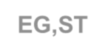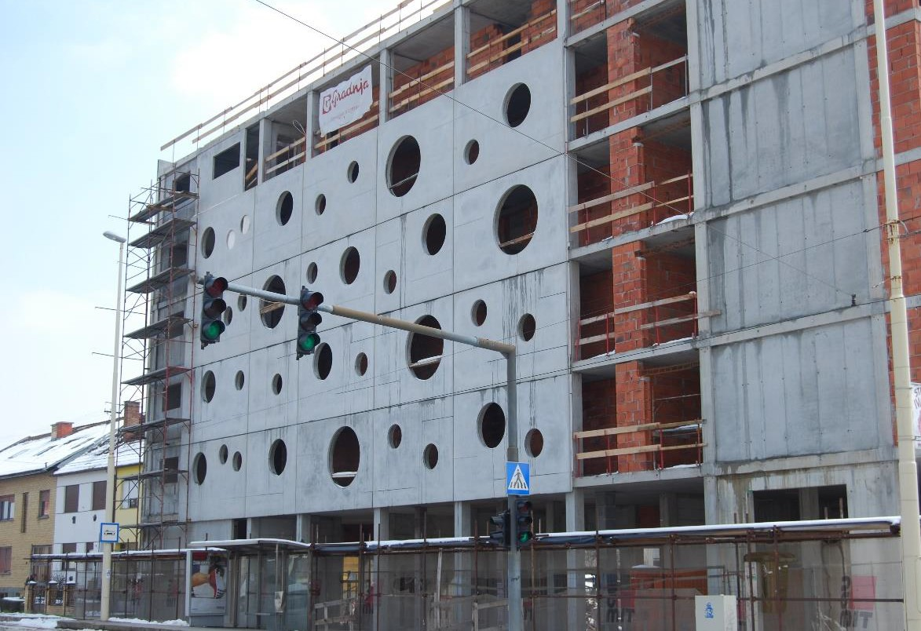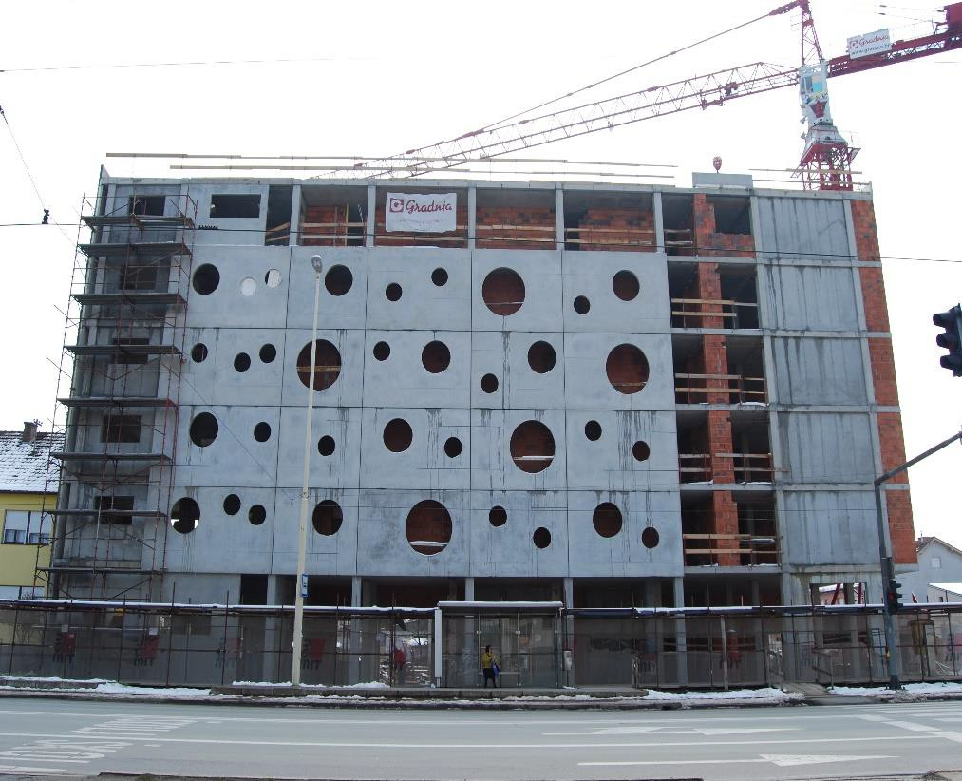The outer façade texture with circle opening

The outer façade texture with circle opening
Façade elements can be with one, two or three
layers.
- The exterior part can be with any texture,
- There are possibility to have pre-defined openings for the doors, windows.

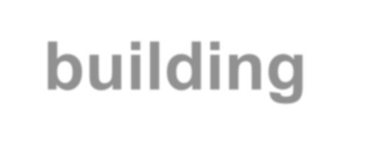Visualization of
process stages

PTS
building technology
Belgrade, Serbia 2021


1 .BASE ASSEMBLY

7.B□LT
1Cl. LATE
12.SAFE

 6.C□RNER C::EJFFER
- SIDE

- SeLIT
B.REJD
- SIDE

9.eLAMP

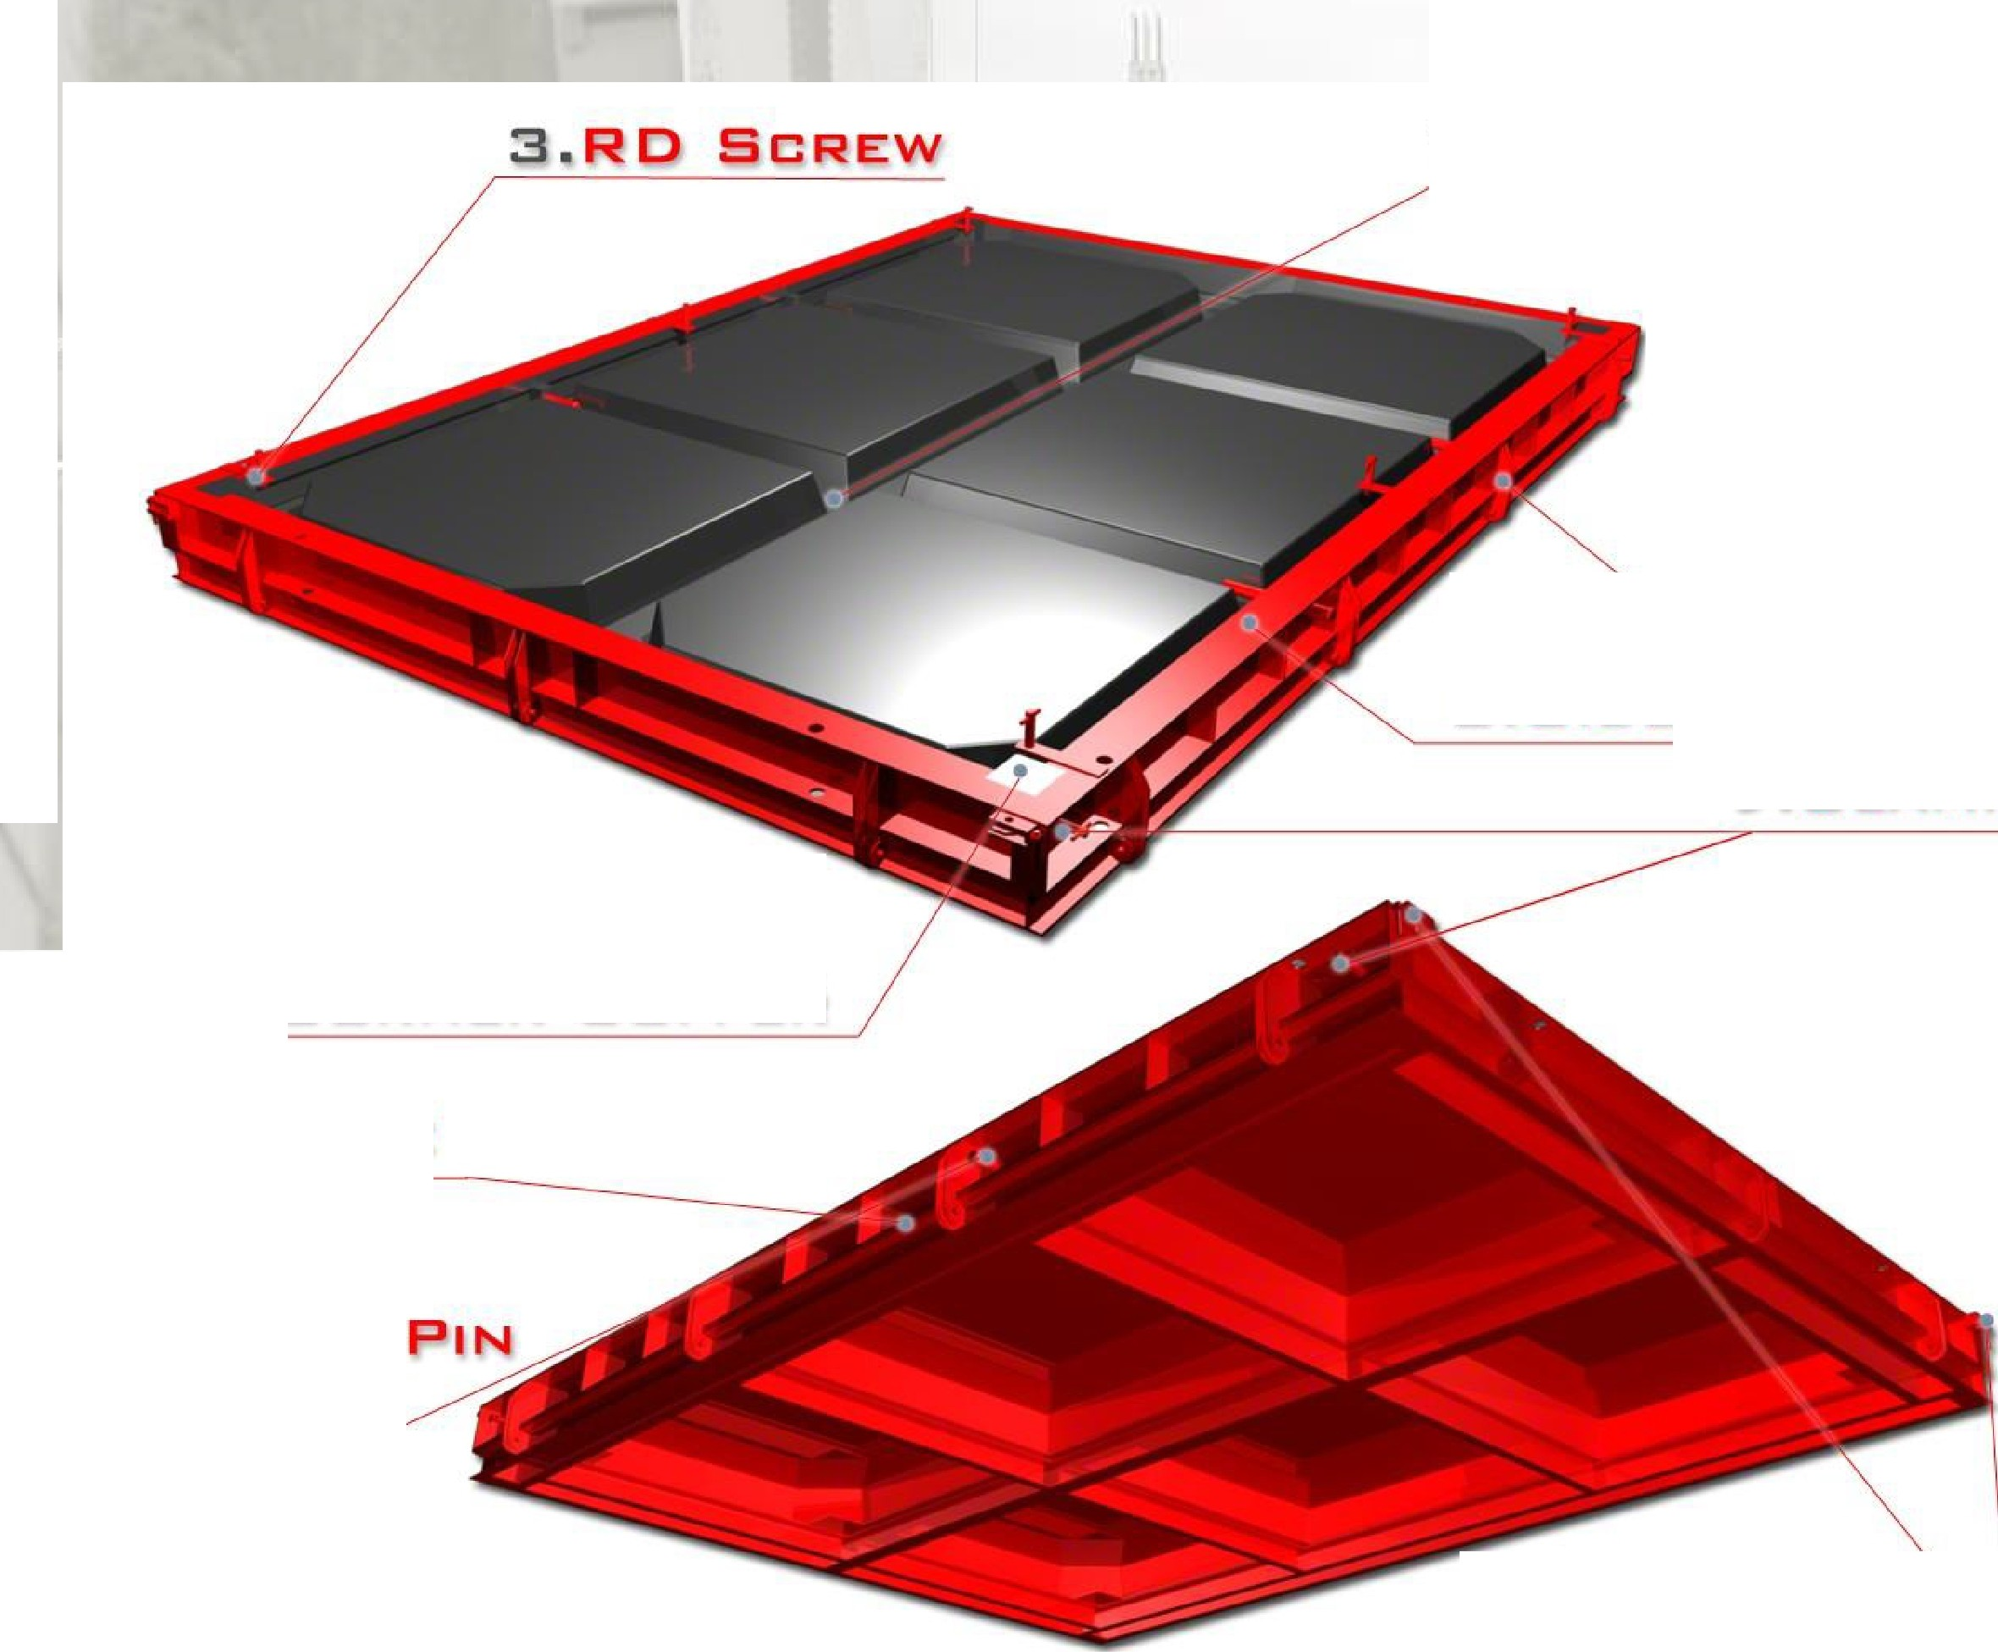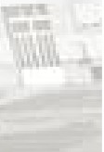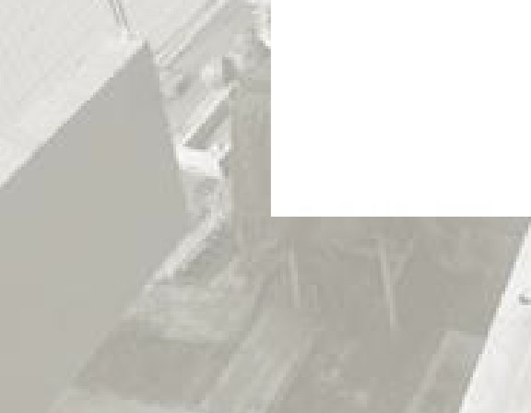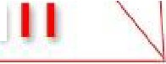

1 1 .CLAMP I

Belgrade, Serbia 2021


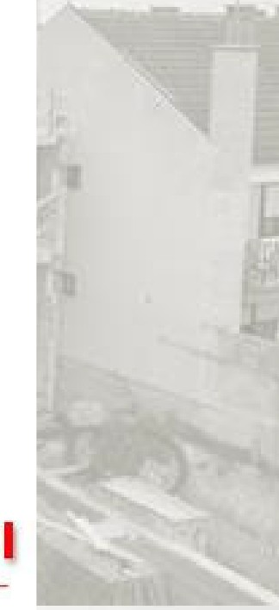
- 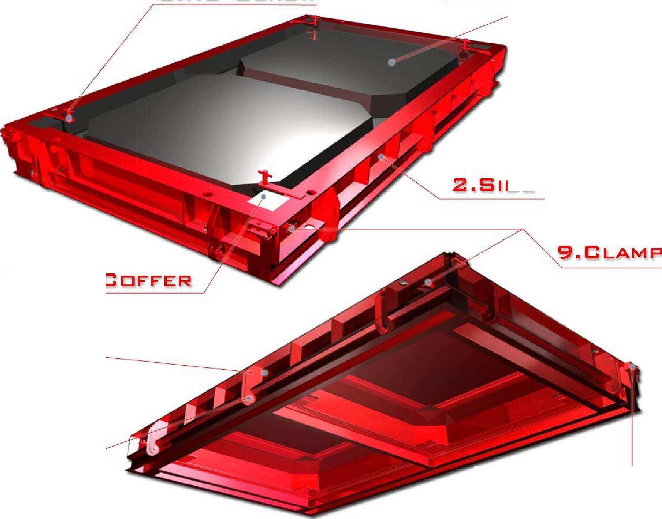RE> SCREW 1 .BASE ASSEMBLY

2.SIDE

- C□RNER COFFER

- SIDE

S.B□L"'f' 7.PLATE

1□.WASHER
B.SAFE

Belgrade, Serbia 2021

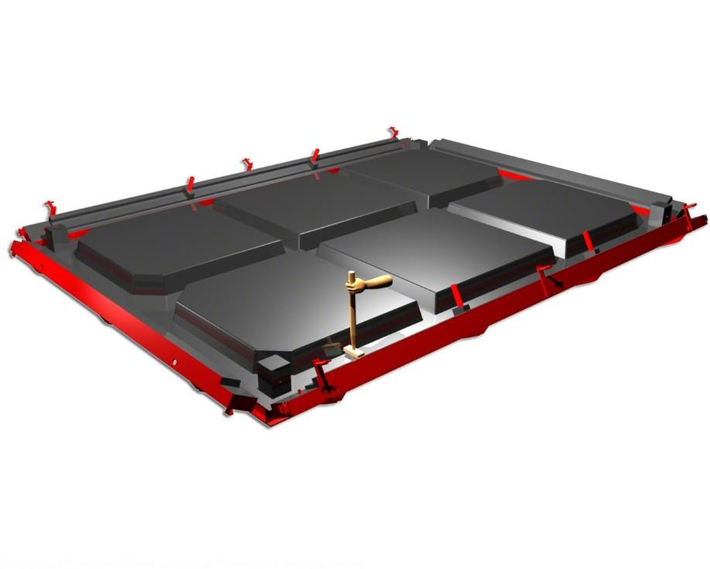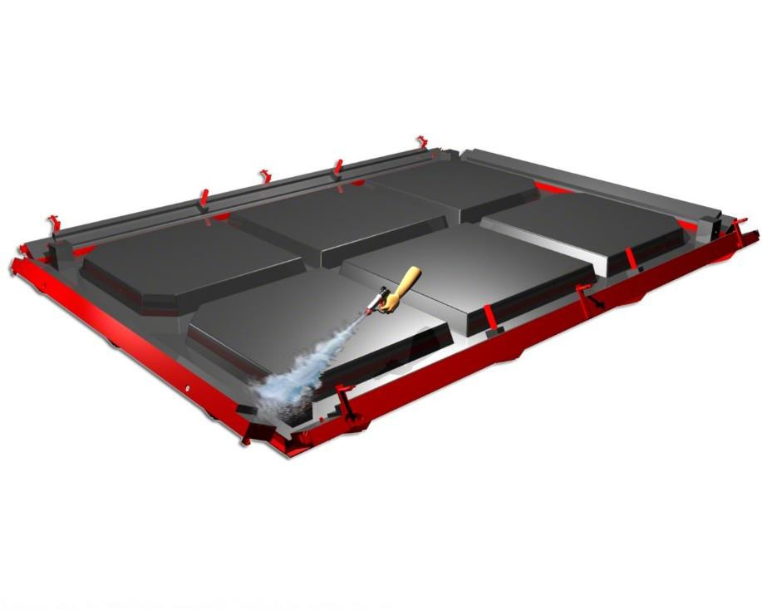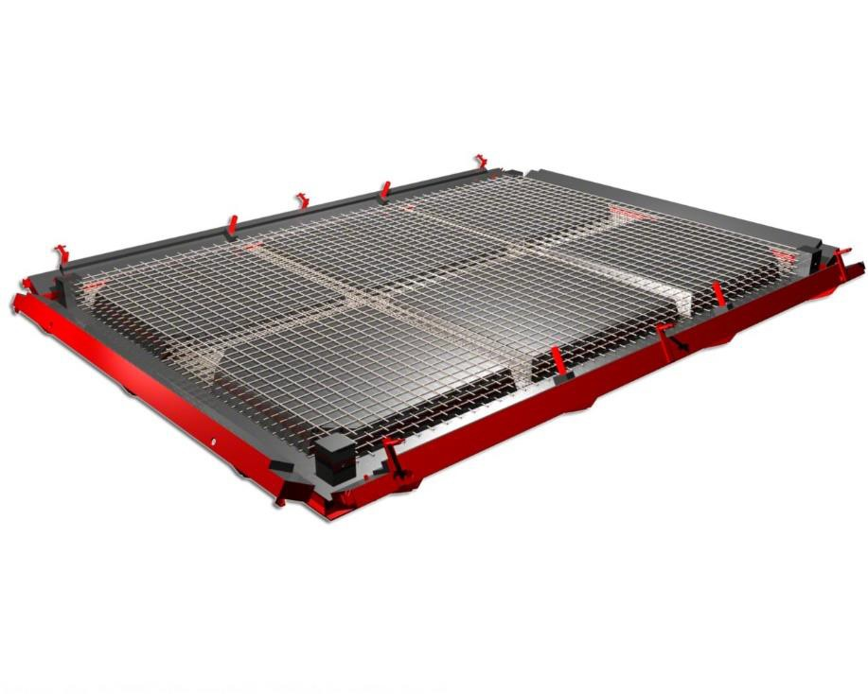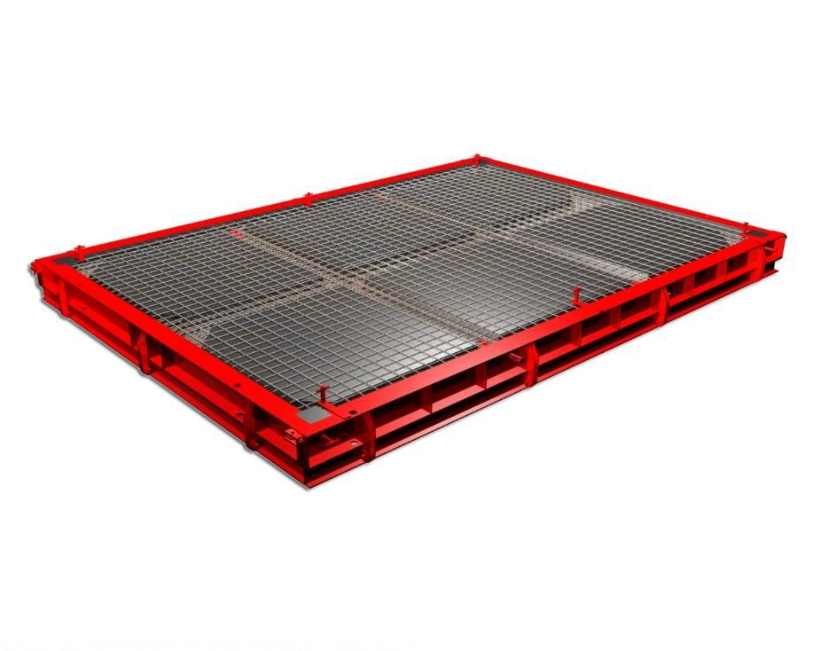

Belgrade, Serbia 2021

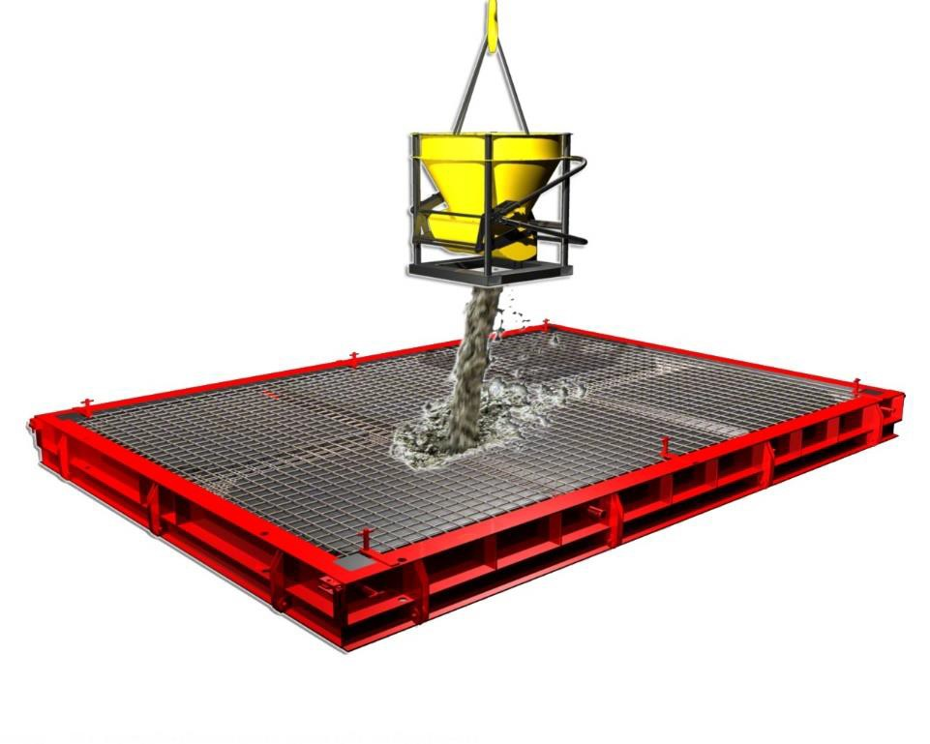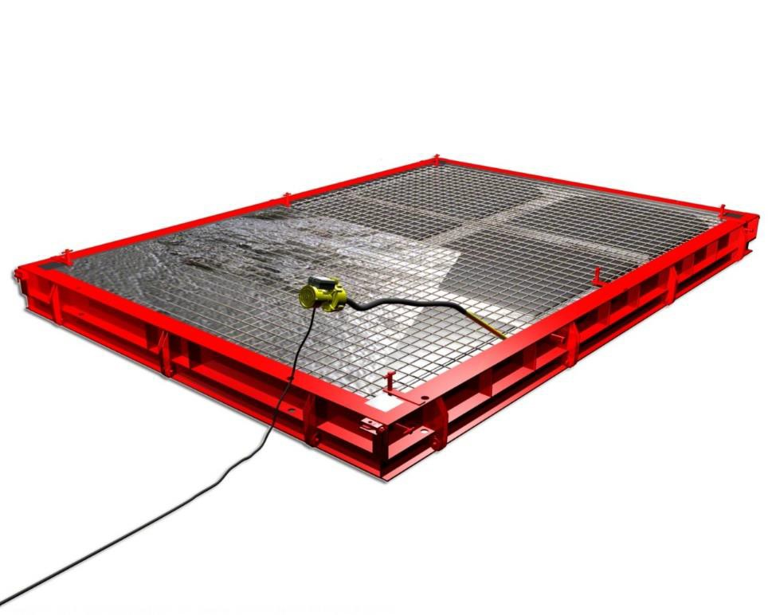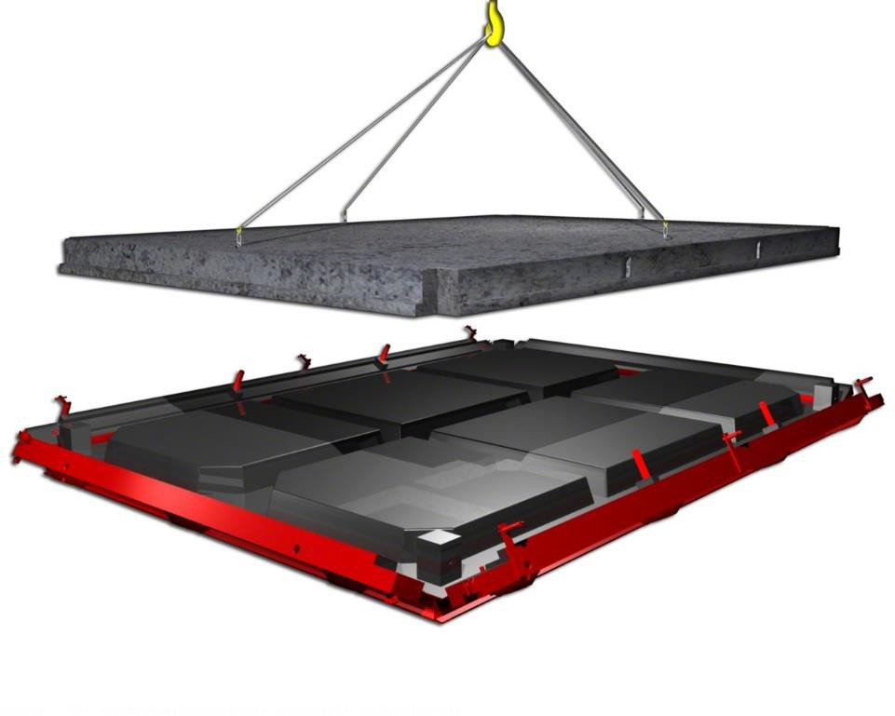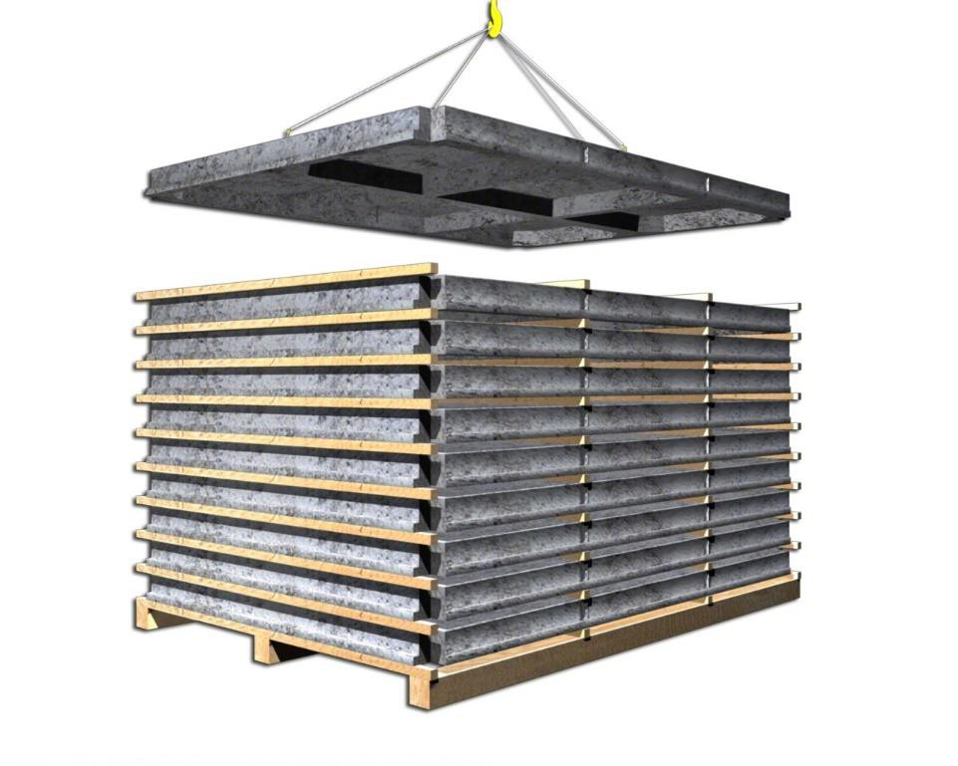

Belgrade, Serbia 2021

From scratch to realization Bungalows Houses-in a row

Belgrade, Serbia 2021

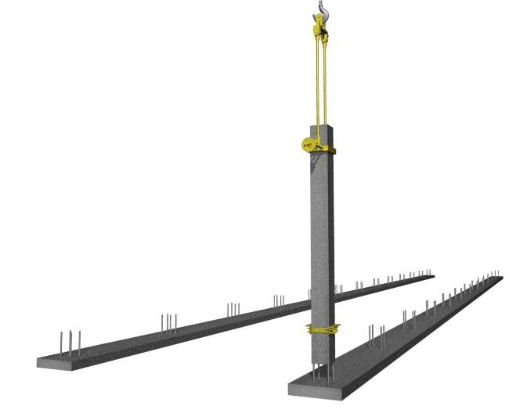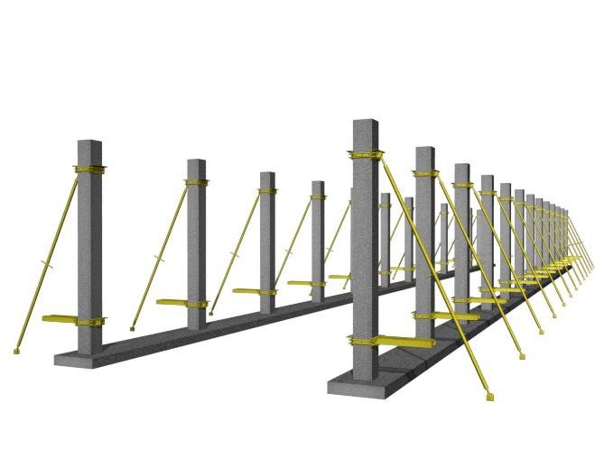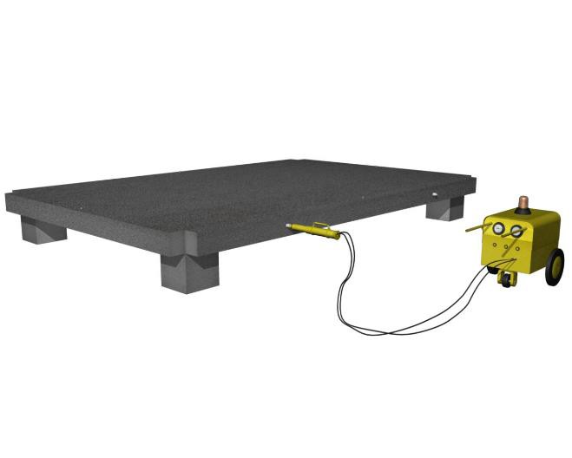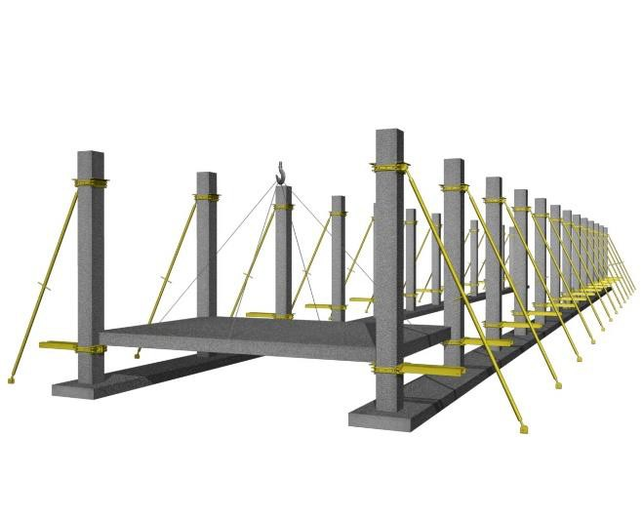

Belgrade, Serbia 2021

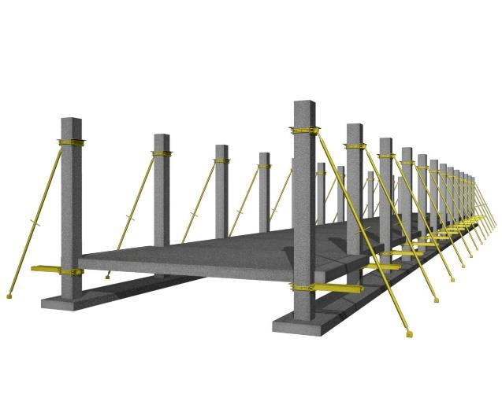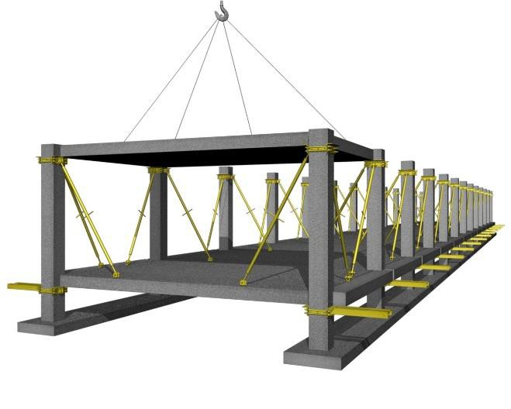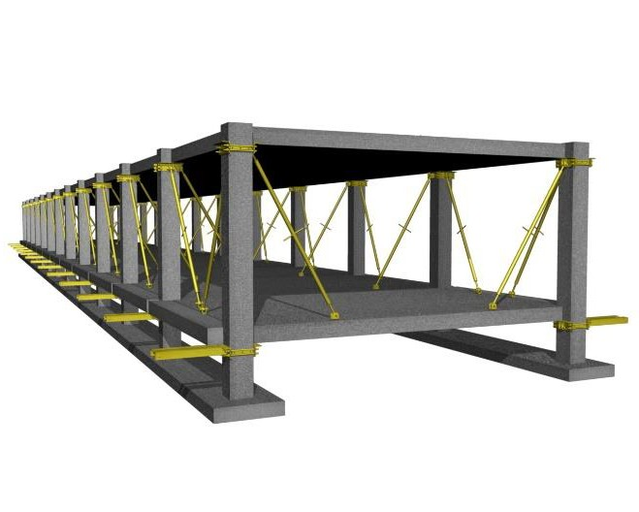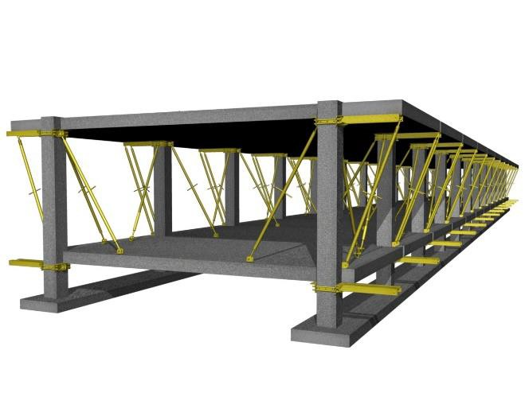

Belgrade, Serbia 2021

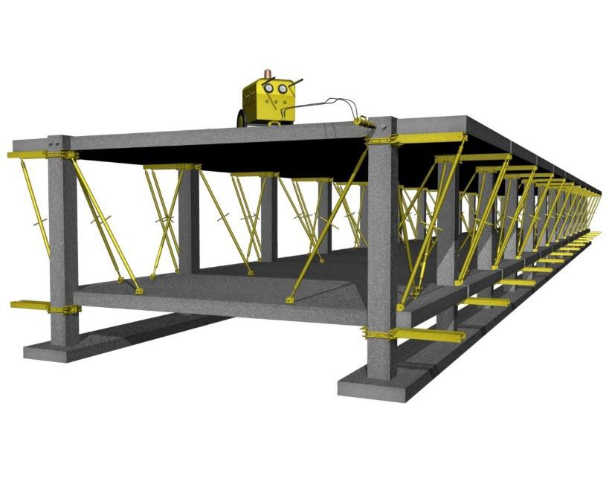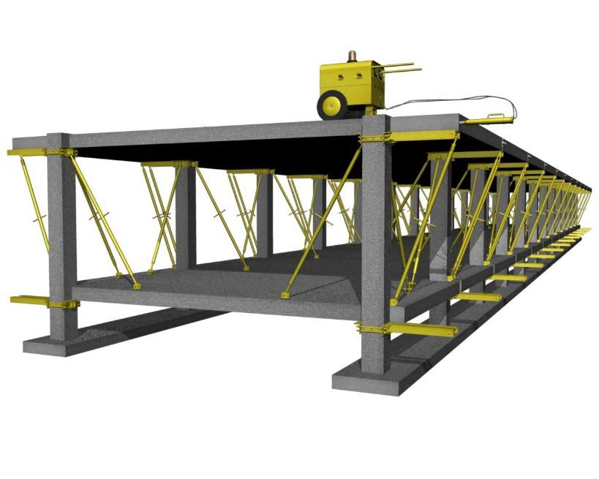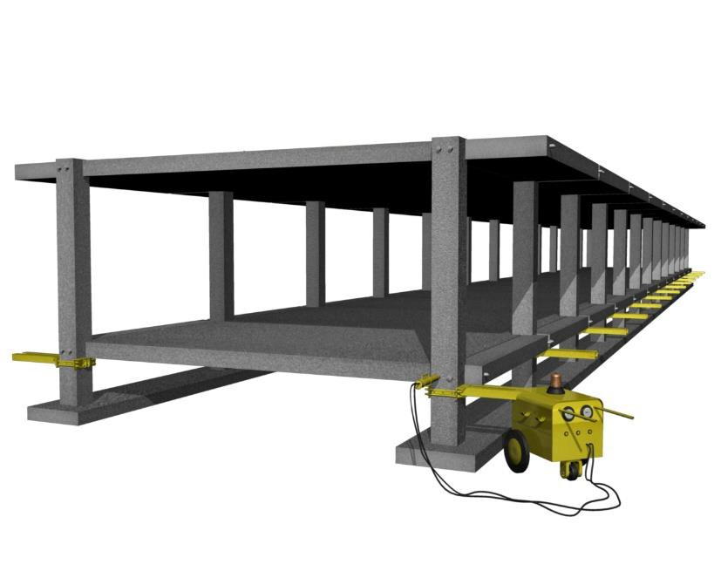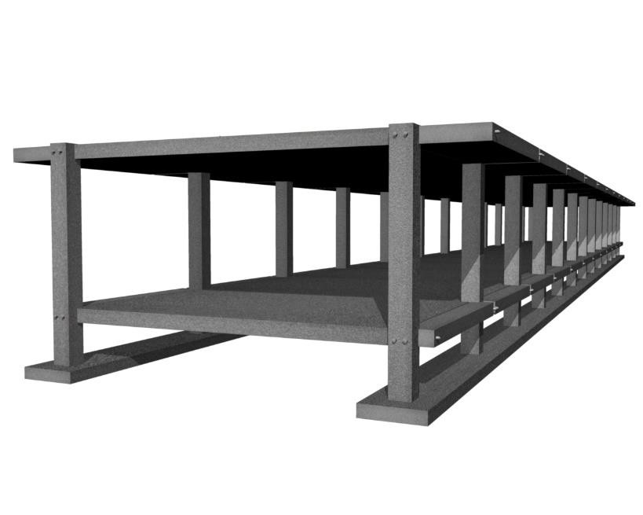

Belgrade, Serbia 2021

Final Remarks

PTS
building technology
Belgrade, Serbia 2021

The experiences of this project show that it is possible to achieve optimization in terms of labour, time and material consumption through use of prefabrication of both structural system and other subsystems (e.g. façade).

In terms of construction waste management and environmental impact, well-organized production facilities and clean assembly-based construction sites show a clear advantage over traditional methods of construction.

The PTS Building Technology proved to be up to the task set before it – enabling the construction of a contemporary-designed residential building in the middle of the urban fabric, with apartments that meet the expectations of modern buyers, in full compliance with valid Worldwide standards and norms.

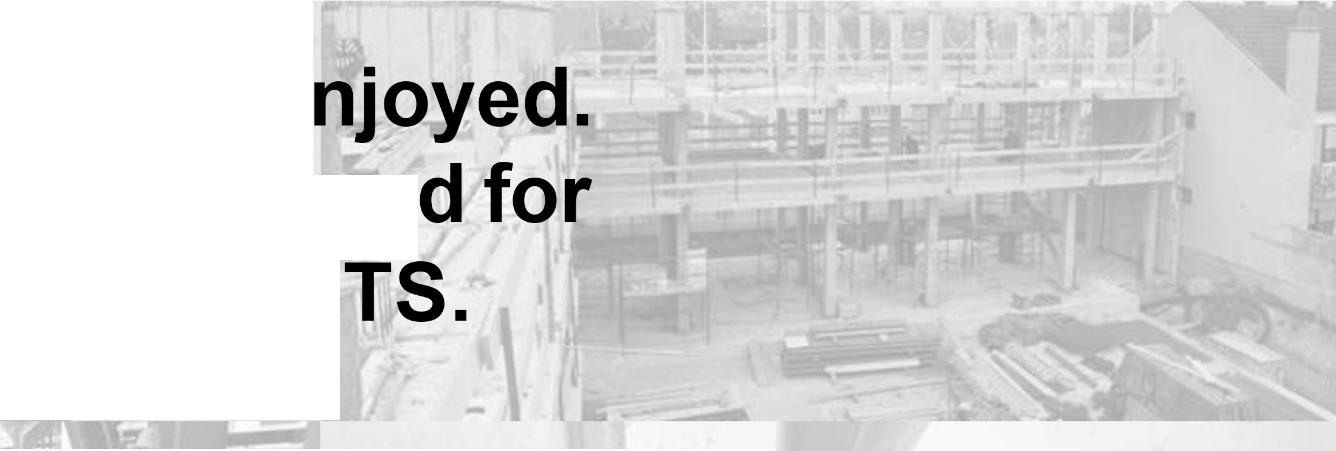Thank you for your attention!

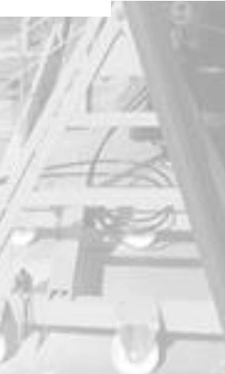
We fiope that you e We are looking forwar implementation of Pi

Theoretical bac ground can be presented on demand.


PTS Building Technology Belgrade, Serbia

Mechanical Engineer M. Stankovic Industrial Designer A. Stankovic
y
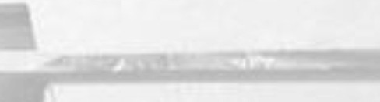/\ACTAl31/il..!,A

